React Basics – Exercises
Exercises and homework assignments for “Full Stack Apps with AI” course at SoftUni.

Link Tree App
Create a React app "Link Tree", designed to share links in social media. Display user profile (picture + name + short bio) + a list of links (icon, title, label):
- Create a reusable LinktreeProfileAvatar component showing a profile picture, name and a short bio
- Create a reusable LinktreeButton component that accepts URL, label, and icon as input parameters (props) and renders ac icon
  - Icons will be a fixed list: Instagram, Facebook, YouTube, TikTok, X / Twitter, etc.
- Create the LinktreeApp component to hold a profile avatar + list of link buttons
- Generate the app as a modern mobile-first layout with a gradient background

Create a New Workspace
Create a new project workspace in Visual Studio Code for your app, e.g., `link-tree-app`:
Create a new sub-folder in the working folder for this exercise:
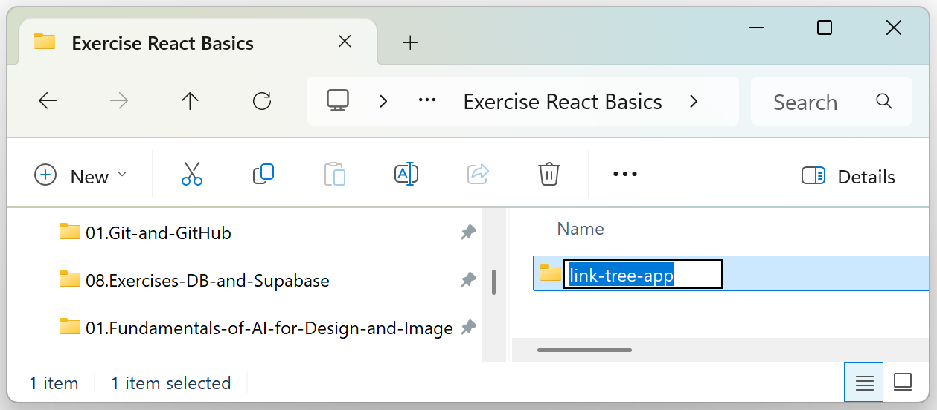

AI Prompt
We shall build the app in two steps:
- View the link tree
- Edit the link tree (profile data + links)
Let's start with the first step: visualize the link tree.
Prompt GitHub Copilot to initialize a Vite React app with TypeScript and implement the Link Tree React app:
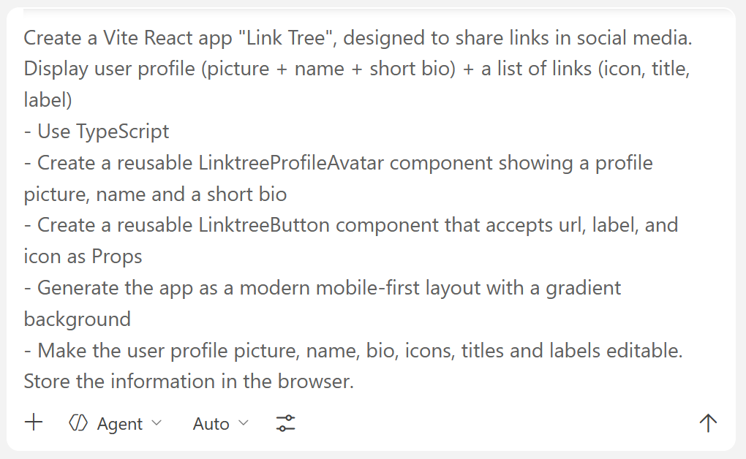

The App in the Browser
This is an example of how the Link Tree app may look like:
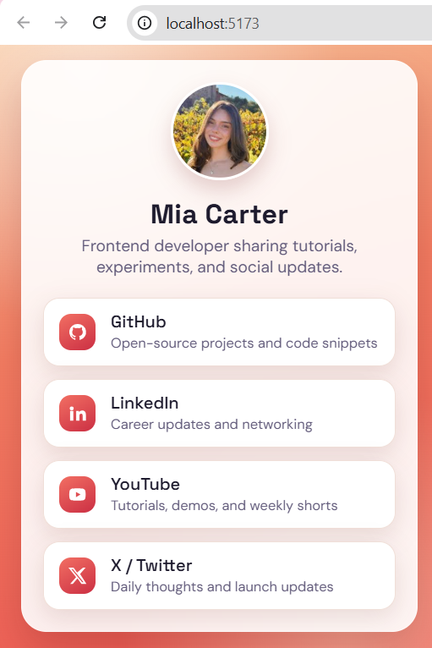

Edit Profile and Links
Now, it's time to implement profile editing. Run an AI prompt:
- Implement functionality: edit the link tree (profile data + links)
This is an example of one possible implementation:
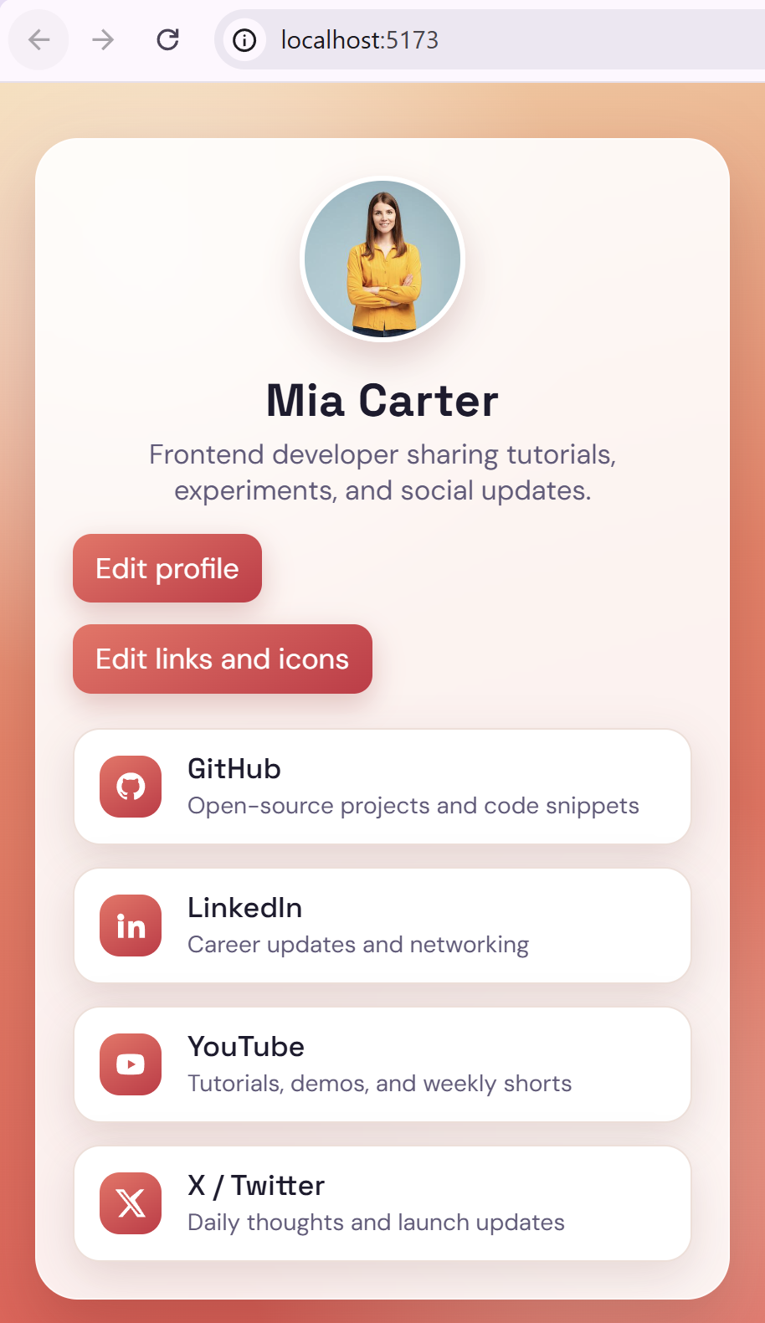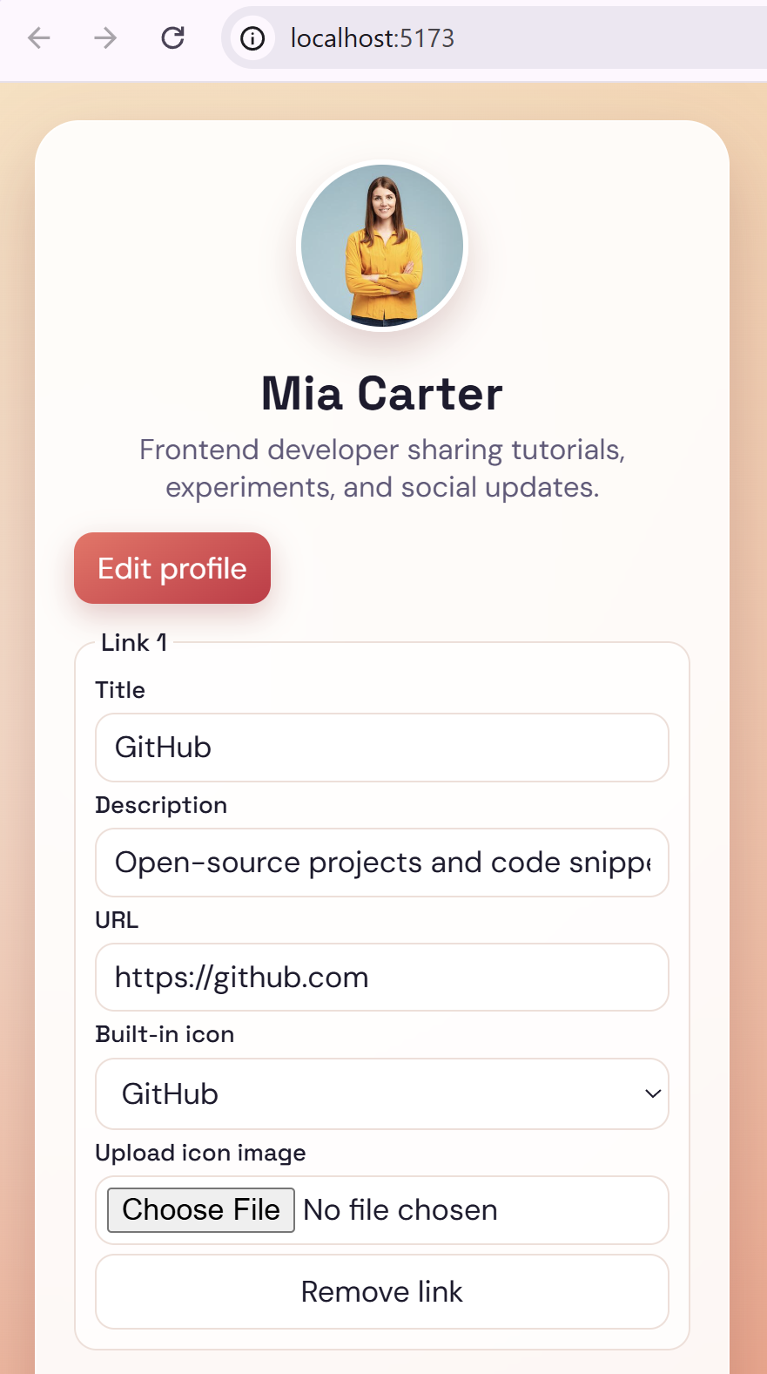

The App on a Mobile Device
If you want to test your application on a mobile device, you can deploy it on Netlify. If you haven’t already registered during the previous course "Software Technologies with AI", this is the first step that needs to be taken. Follow the instructions to set up your Netlify profile. When you are ready, simply drop the app files to deploy. Go to Projects and upload the folder with the app files:
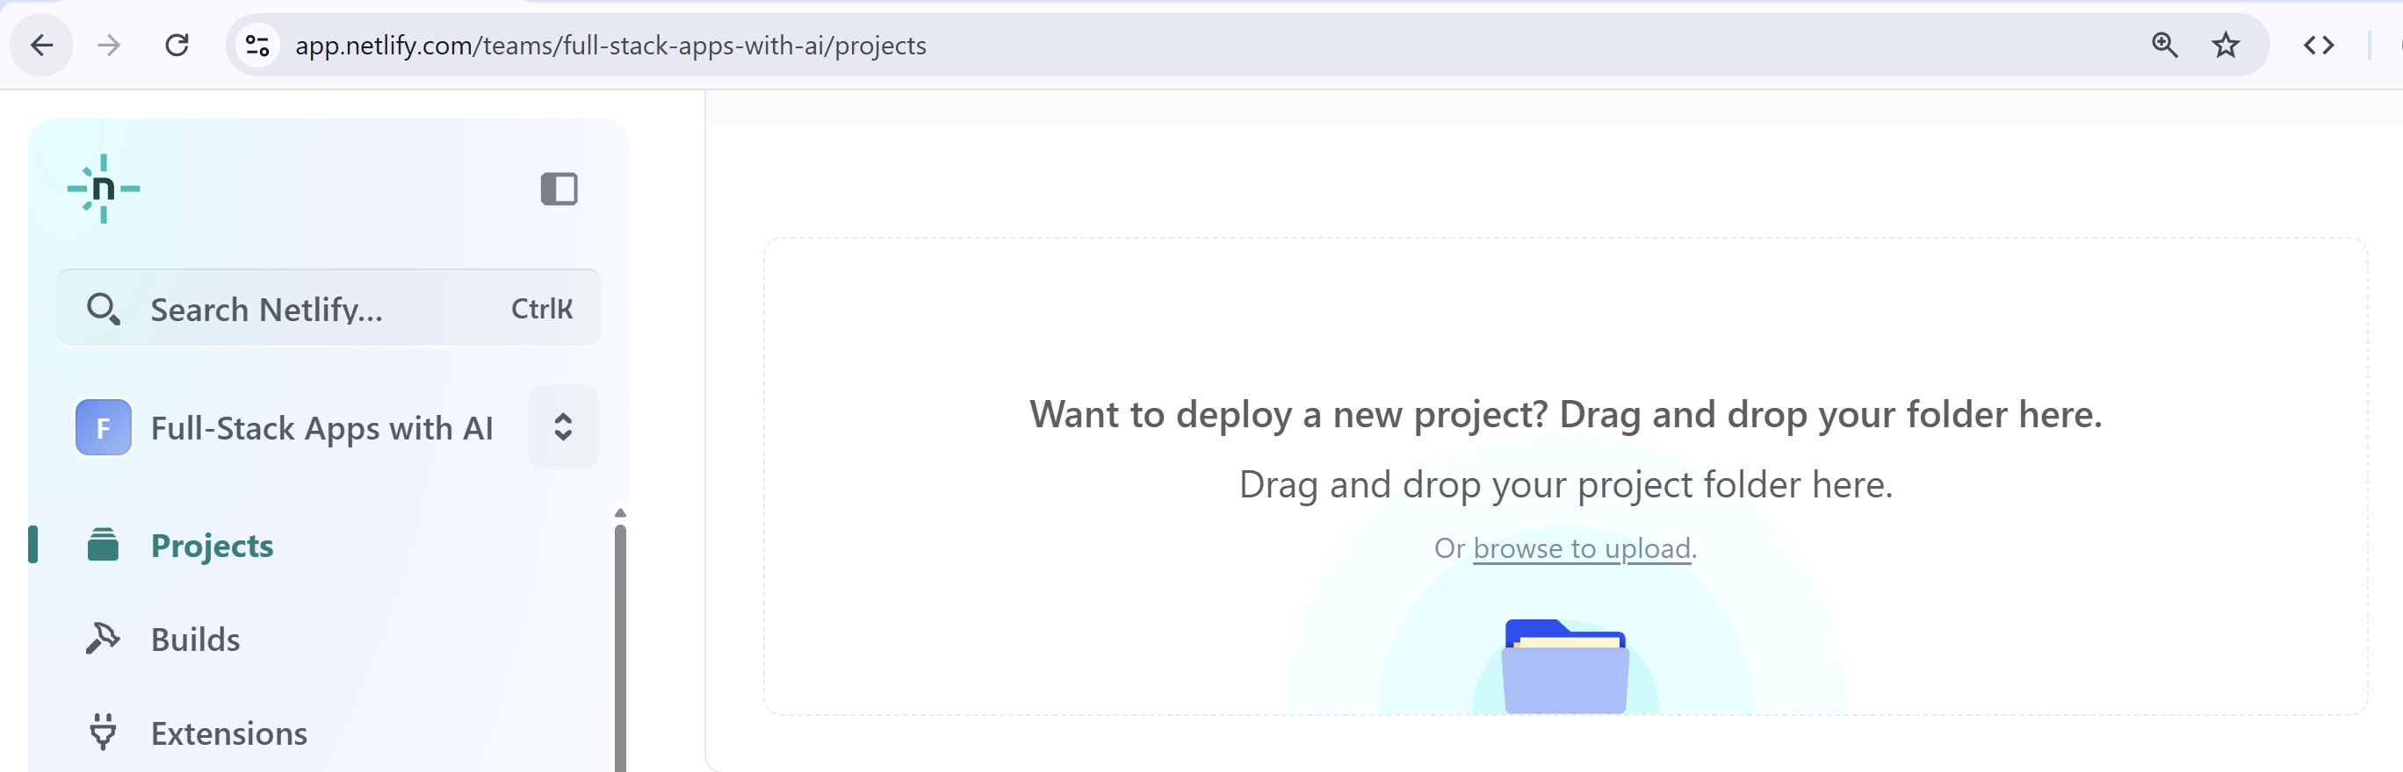
After the app has been deployed successfully, open the generated link on a mobile device to test it.
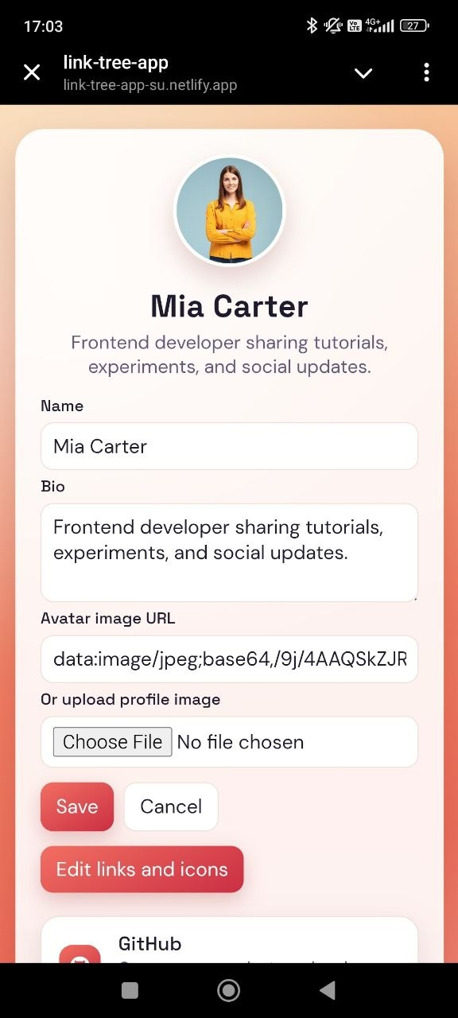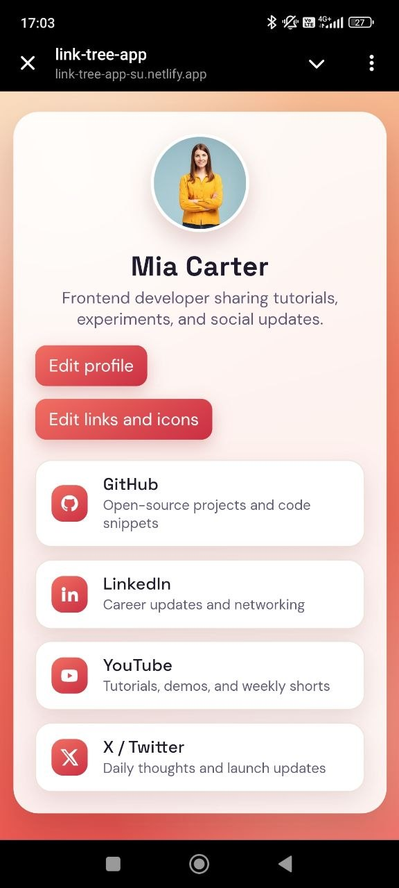

Products Editor App
In a new folder and using an AI coding agent, create a React app "Products Editor". It’s better to work in steps for this exercise. This way every step will be verified:

Step 1: Create React App
Initialize a new React front-end app "Products Editor":
- Use React, TypeScript and Vite, with Bootstrap.
- Implement modern, responsive UI, with icons, animations and toast notifications.

Step 2: Implement Data Layer
Implement app's data layer.
- Hold all app data in the browser local storage.
- Products have name, description, photo (URL), price, currency, unit.
- Initially, generate sample data for testing (a few sample products).

Step 3: Implement App UI
Implement app's UI as React components:
- Implement the app front-end (React components) to see how the app will look like when it's implemented.
- Don't implement the app functionality, it will come later. Implement just the UI.

The App in the Browser
This is how the app may look in its initial stage. The form for adding products stays on the left, next to the product cards. However, this is not a practical approach and can be optimized.
This is what we wanted: only the React UI components, without working functionalities. The CRUD functionalities are still not implemented. Images cannot be uploaded.
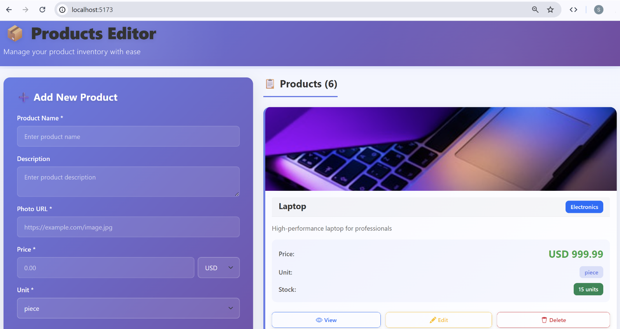

Step 4: Implement List Products
Implement "List Products" functionality:
- List all products as a table with [Add] / [Edit] / [Delete] buttons.
- Don't implement the buttons actions, just visualize the buttons in the table.

The App in the Browser
The products are listed in a table, next to the tab for adding products. However, the UI can be improved by making the functionality for adding products in the form of a popup.
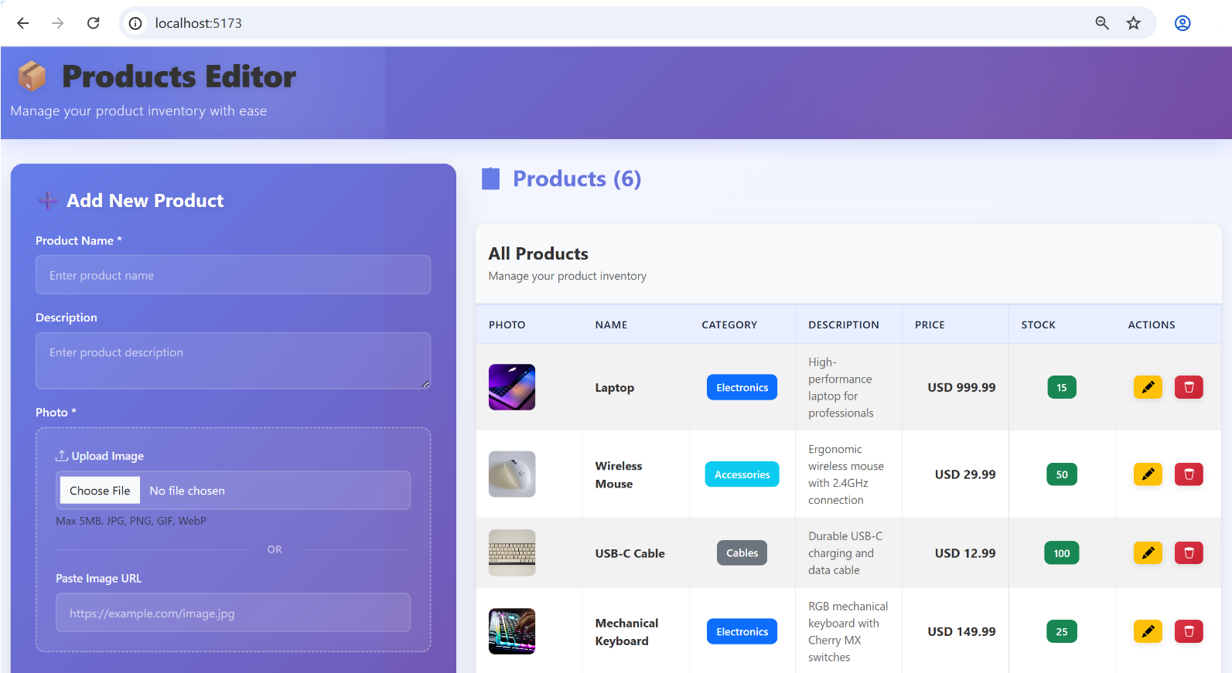

Step 5: Implement Add / Edit / Delete
- Implement add / edit / confirm delete operations with popup dialogs.

The App in the Browser
The products are easier to browse through. All functions open as popup windows.
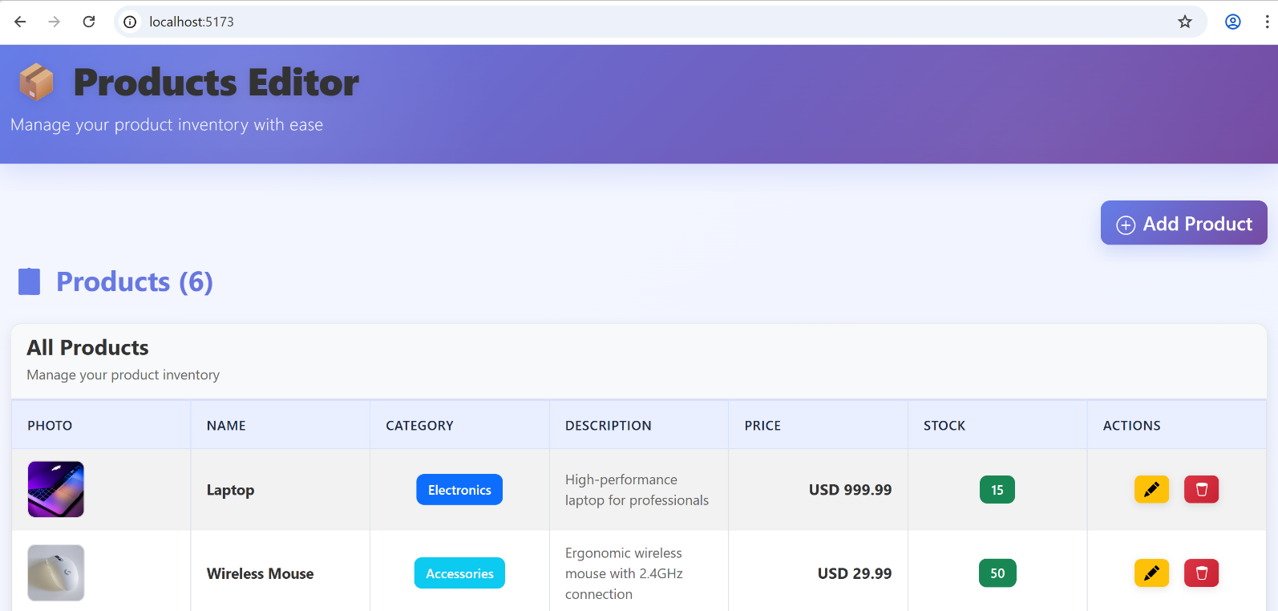

The Add / Edit Popups
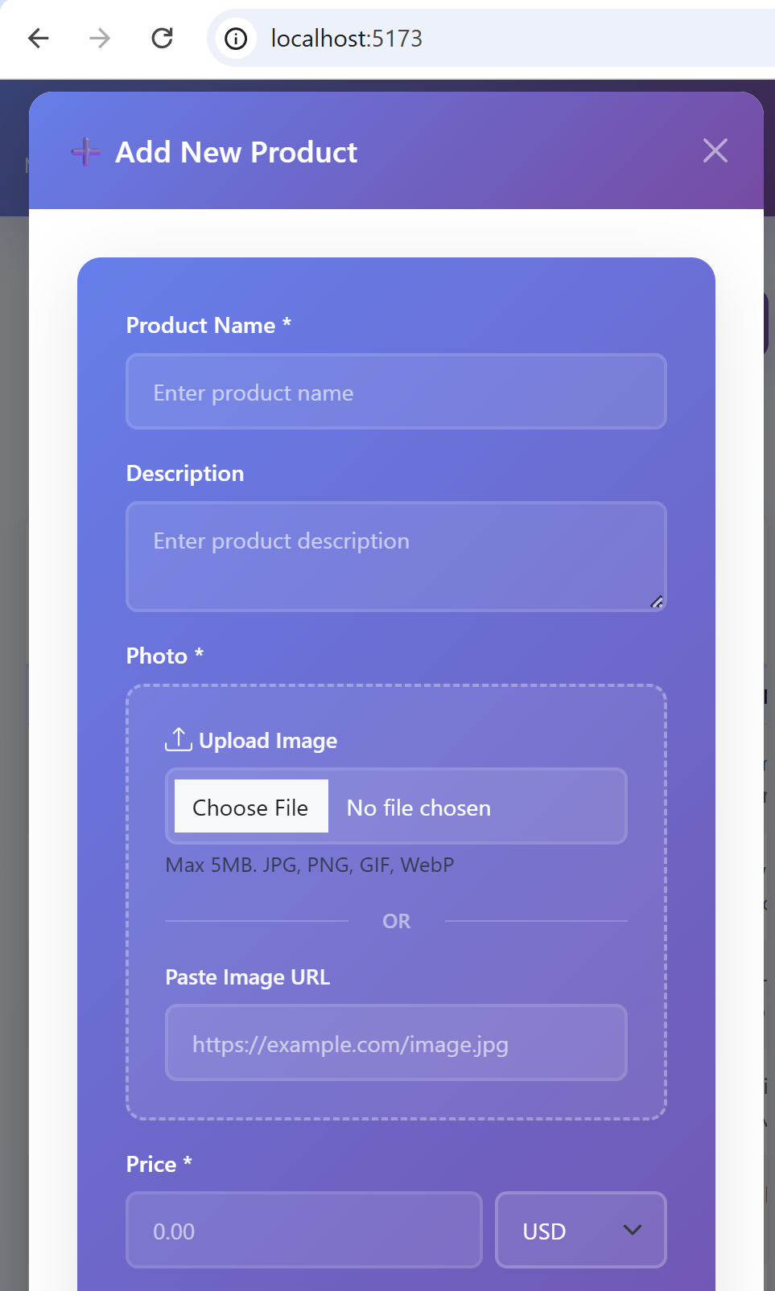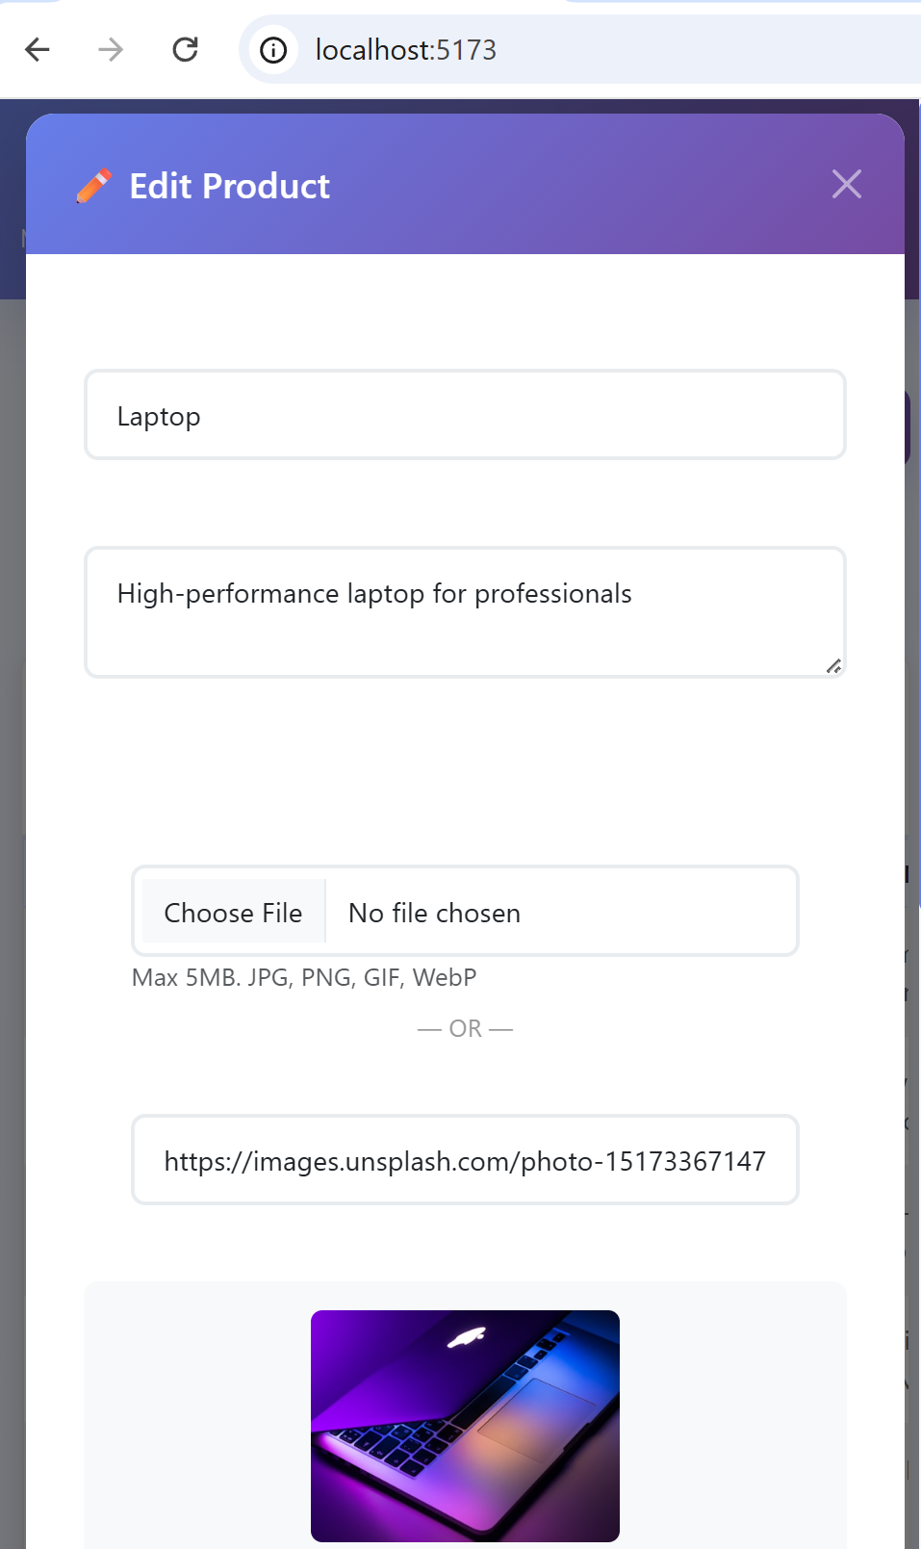

Step 6: Implement Image Uploads
- Implement "image uploading" (choose image URL or Upload Image).
- Keep the uploaded images in the browser local storage as "data URLs", along with the products.

Step 7: Modular React Components
Split the UI into modular React components, e.g. product editor app, product, product editor form, etc.
This should not edit the application itself but improve the file structure in VS Code:
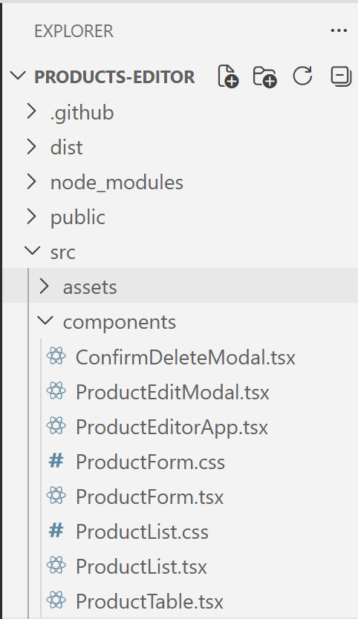

Employees Editor App
Using an AI coding agent, create a React app "Employees Editor" to edit company departments and a hierarchy of employees, working in these departments:
- Use React, TypeScript and Vite, with Bootstrap.
  - Implement modern, responsive UI, with icons, animations and toast notifications.
  - Structure the app in modular React components. Avoid large and complex components. Keep the app structure and code simple, understandable and maintainable.
- Hold all app data in the browser local storage (employees, departments).
  - Departments: name, description, manager (employee, optional)
  - Employees: name, job title, department (optional), email (optional), phone (optional), manager (optional)
  - Initially, generate sample data for testing (a few sample departments with employees)
- Implement the app layout: header, footer, two tabs: Departments | Employees
- Employees tab: a React component to list all employees as a table with [Add] / [Edit] / [Delete] buttons
- Departments tab: a React component to list all departments as a table with [Add] / [Edit] / [Delete] buttons.
- Use popup dialogs to implement add / edit / confirm delete operations.
- When deleting an entity, assign undefined to all its dependent entities.
  - For example: if the department manager is deleted, leave the department with no manager.
- Implement "Choose an Employee" popup with all employees listed with a search filter.
- Implement "Choose a Department" popup with all departments listed with a search filter.
- Implement modern UI design, following the industry best practices for UI and UX.

The AI Prompt
We have very clear and detailed description of the app, so we can try to AI generate the app in one shot, with a single prompt. We shall use a powerful AI agent, in thinking mode, because of the app complexity. Let's try:
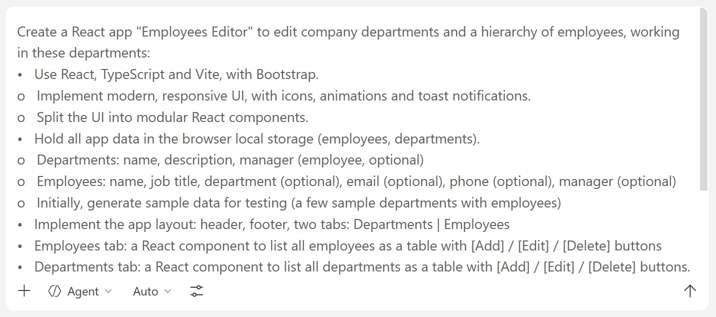

The App in the Browser
This is how your app may look like at the end in your Web browser.

Departments Tab
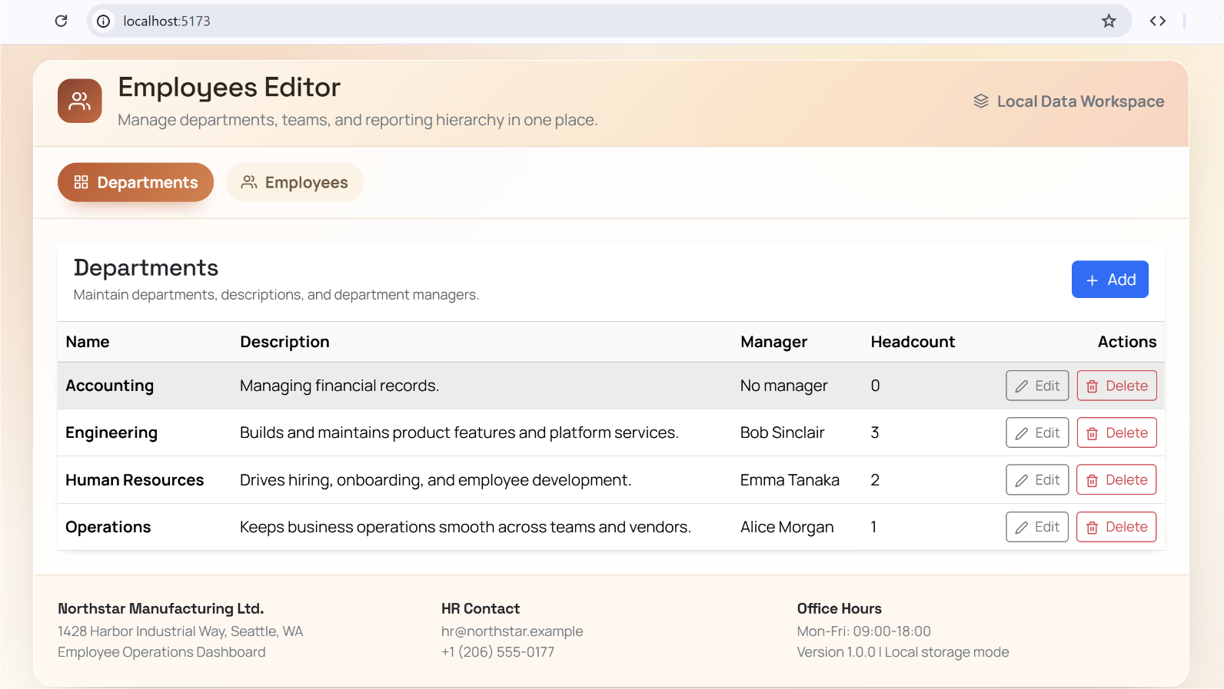

Employees Tab
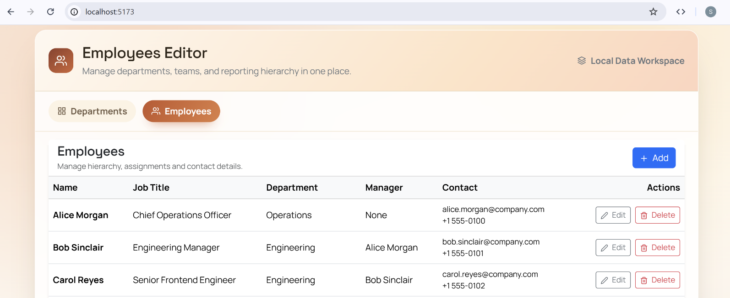

Add Department / Employee
Popup dialogs to add an employee / department.
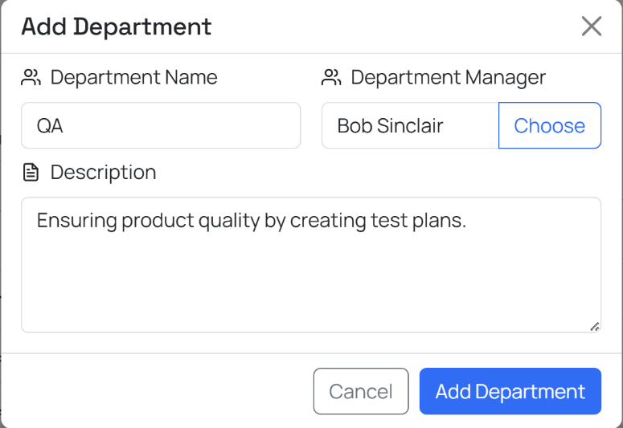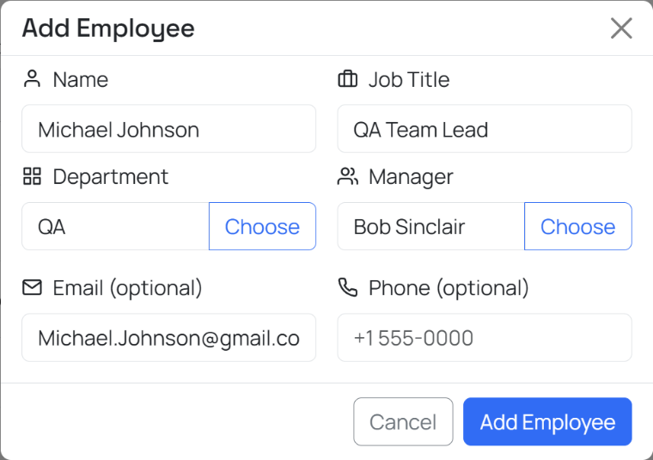

Choose Department / Employee
This popup dialog opens when details about departments and employees are filled in or edited.
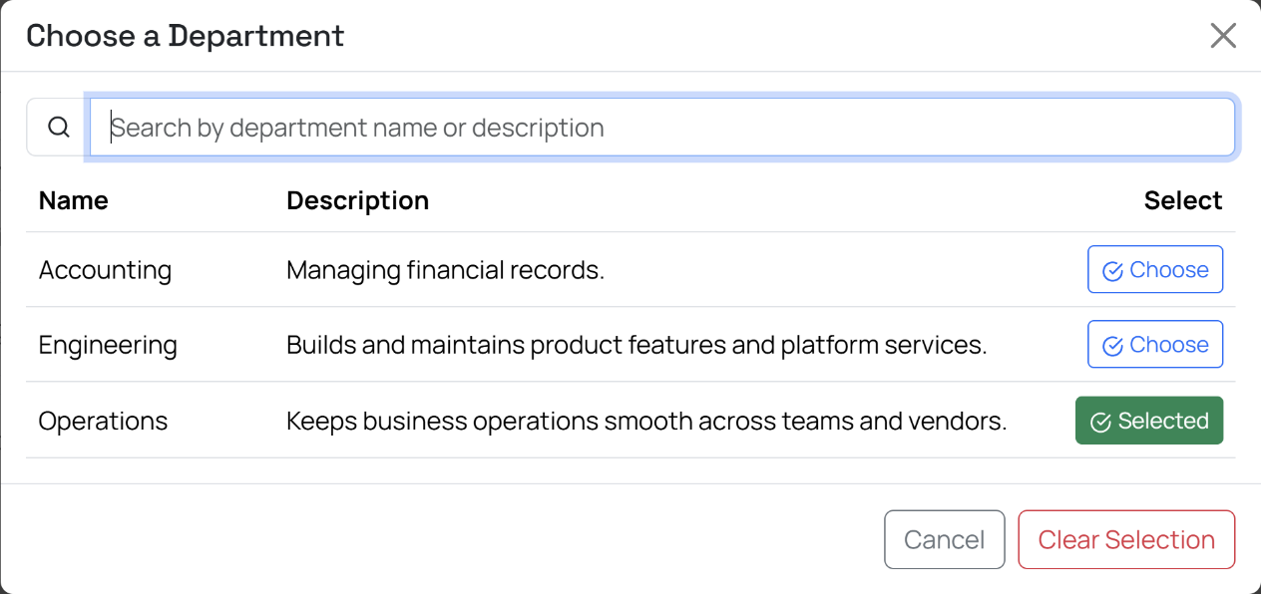
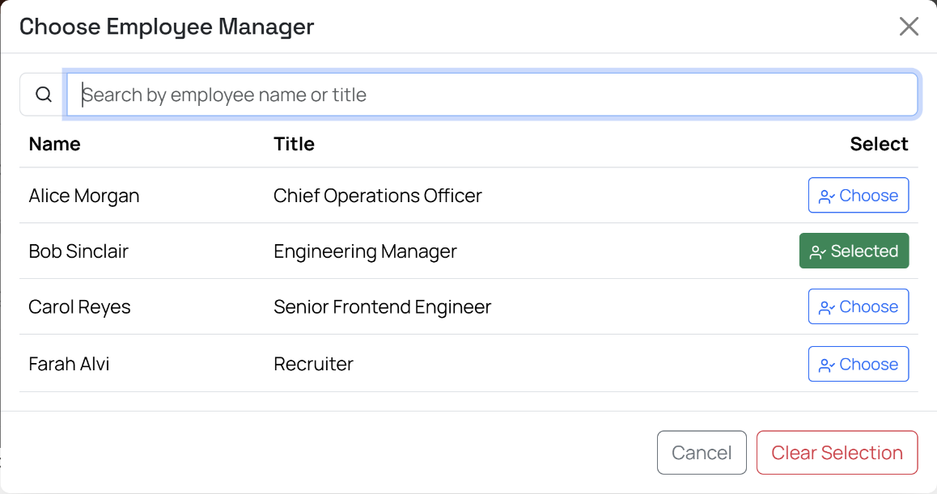

Edit Department / Employee
Popup dialogs to edit an employee / department.
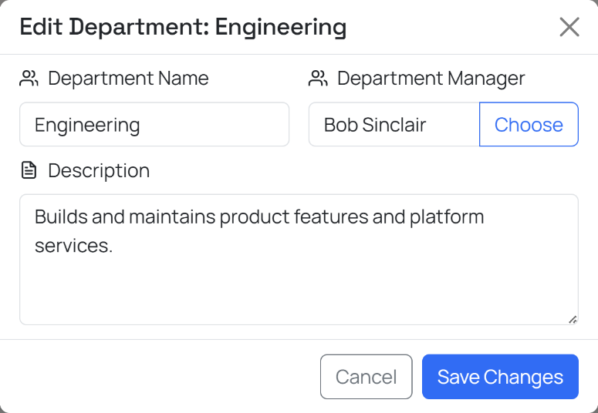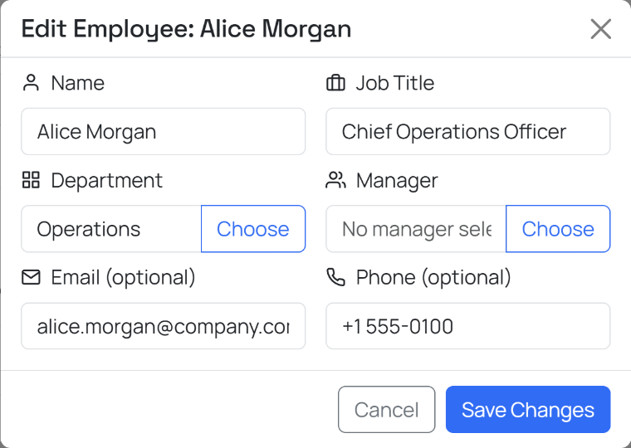

Invoice Tracker App
Your goal is to create an "Invoice Tracker" app (based on React), which will hold and track the invoices of a certain company (invoices, clients, products). These screenshots will give you an idea of what we want to build at the end:
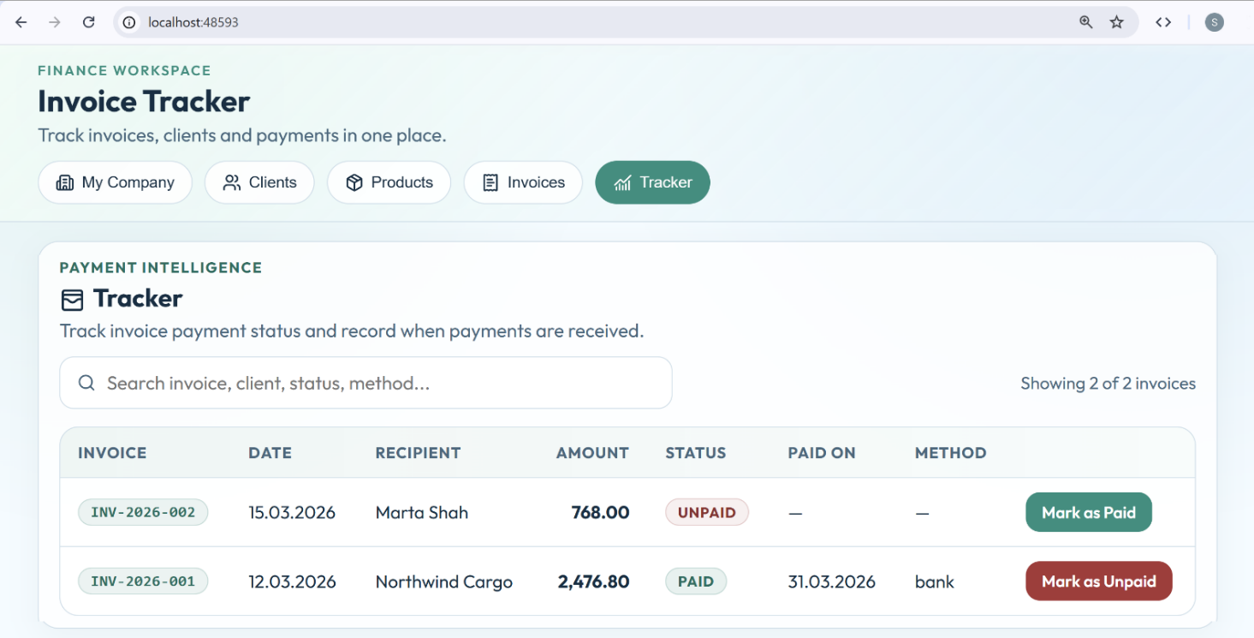
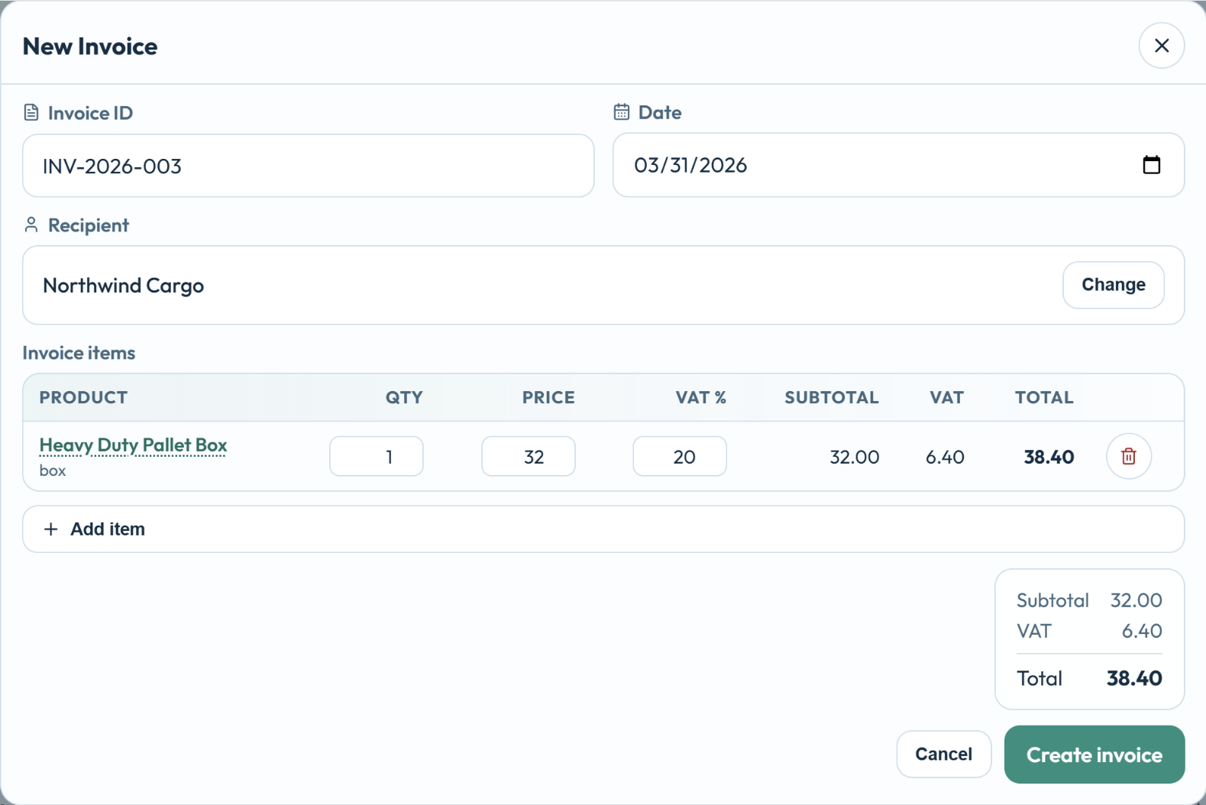
To build the app, follow the steps below:

Step 1 – Setup App and Layout
Create an empty VS Code workspace.

React App with TypeScript
Create an empty React + TypeScript + Vite app.
- Implement modern, responsive UI, with icons, animations and toast notifications.
- Split the UI into modular React components.

App Layout
Implement the app layout, the main app screens and navigation:
- Implement app layout with header + footer + content.
- In the app header implement tabs navigation.
- Implement several tabs (initially empty), which will hold the different screens of the app:
  - My Company (company details + app settings)
  - Clients (company clients and persons)
  - Products (products, categories and suppliers)
  - Invoices (invoices)
  - Tracker (the invoice payments tracker)
- Keep the code for each tab in a separate React component: CompanyEditor, ClientsEditor, …
- Use a full-width layout to render tabs content.

The AI Prompt
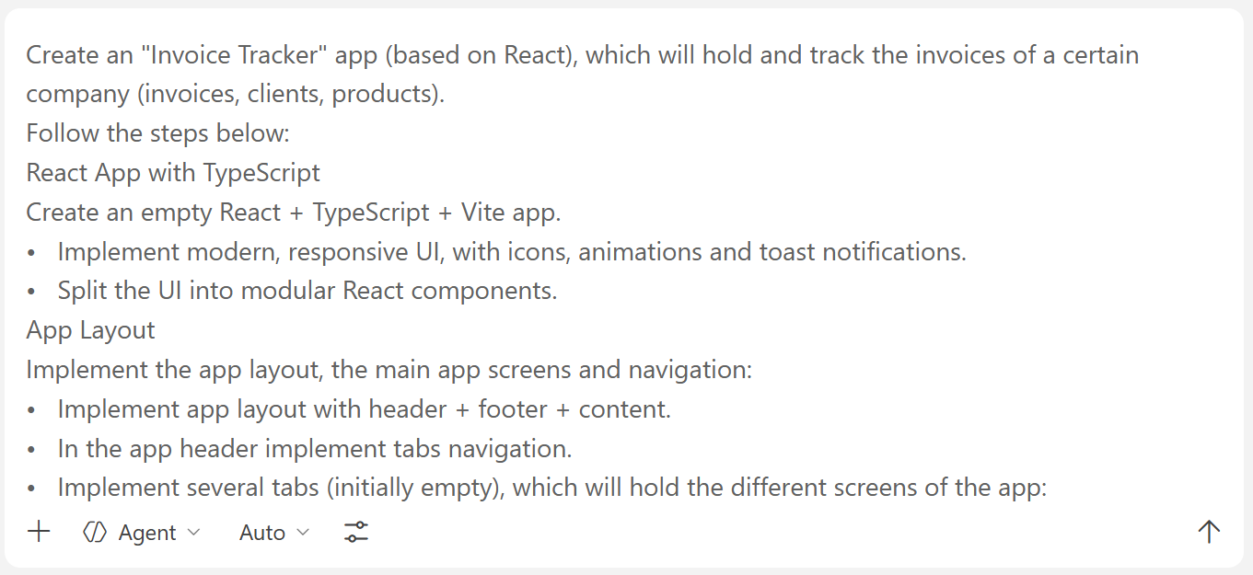

The App in the Browser

My Company Tab
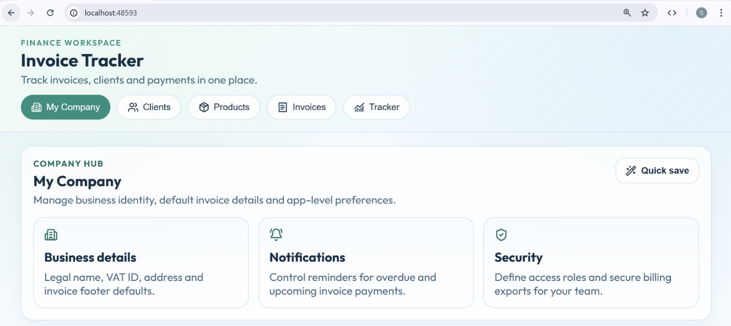

Products tab
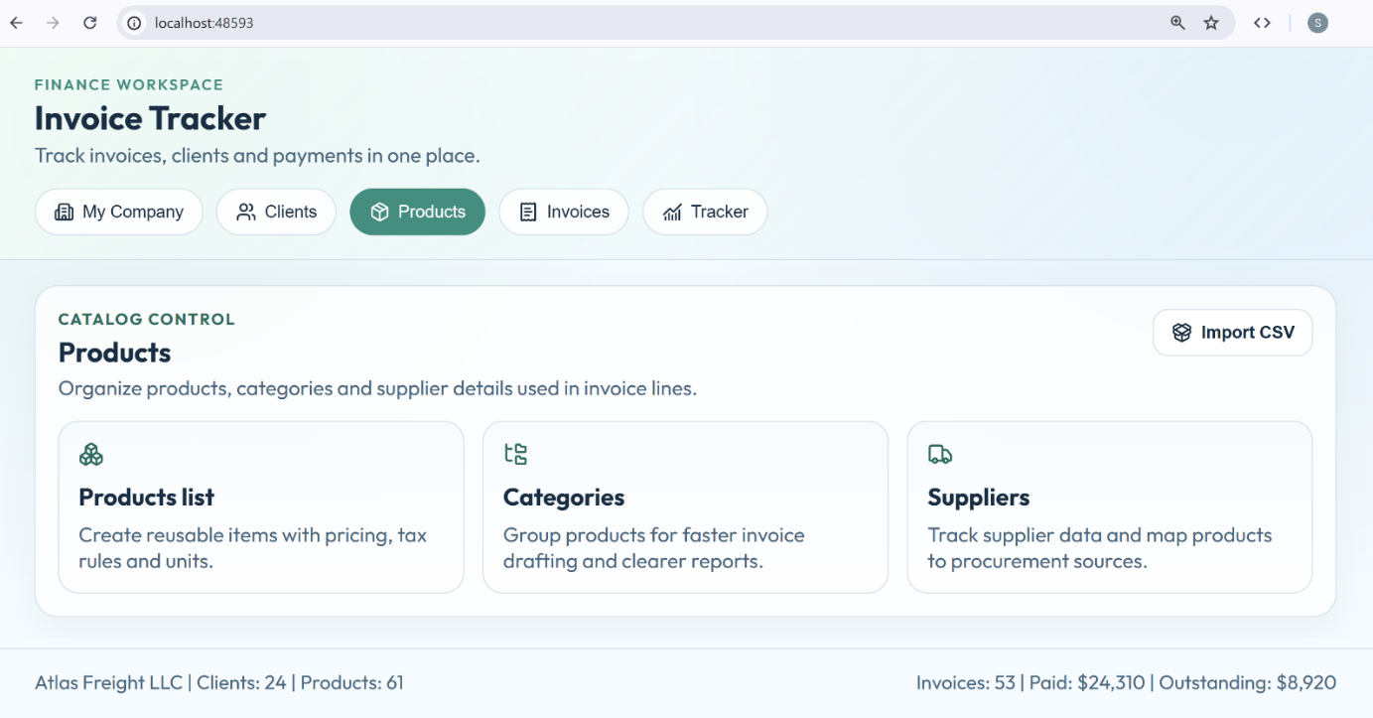

Step 2 - App Data Layer
Define the data layer (data store) of the invoice tracker app as TypeScript data types:
- Define type: Company {name, id, tax id, address, manager, IBAN}
- Define type: Person {name, personal id, address}
- Define type: Client {Company | Person}
- Define type: Supplier {name, description, contact person, phone, email}
- Define type: ProductCategory {name, description}
- Define type: Product {name, price, currency, unit, supplier, category}
- Define type: Invoice {id, date, issuer, recipient, items, amount subtotal, VAT, total amount}
- Define type: InvoiceItem {product, quantity, sale price, value without VAT, VAT rate, VAT value, value with VAT}
- Define type: PaymentMethod {name, description} (bank, card, cash)
- Define type: InvoicePayment {invoice, datePaid, paymentMethod}
- Define type: Currency {name, description} (EUR, USD, GBP)
- Define type: AppSettings {defaultVATPercentage, currencies}
- Keep code for the data layer in a separate folder "data".
- Keep all app data in the browser's local storage (no database yet): companyProfile, appSettings, clients, suppliers, categories, products, invoices, paymentMethods, invoicePayments, etc.
- Initially, generate sample data, so that the app will not be empty at the start.

The AI Prompt
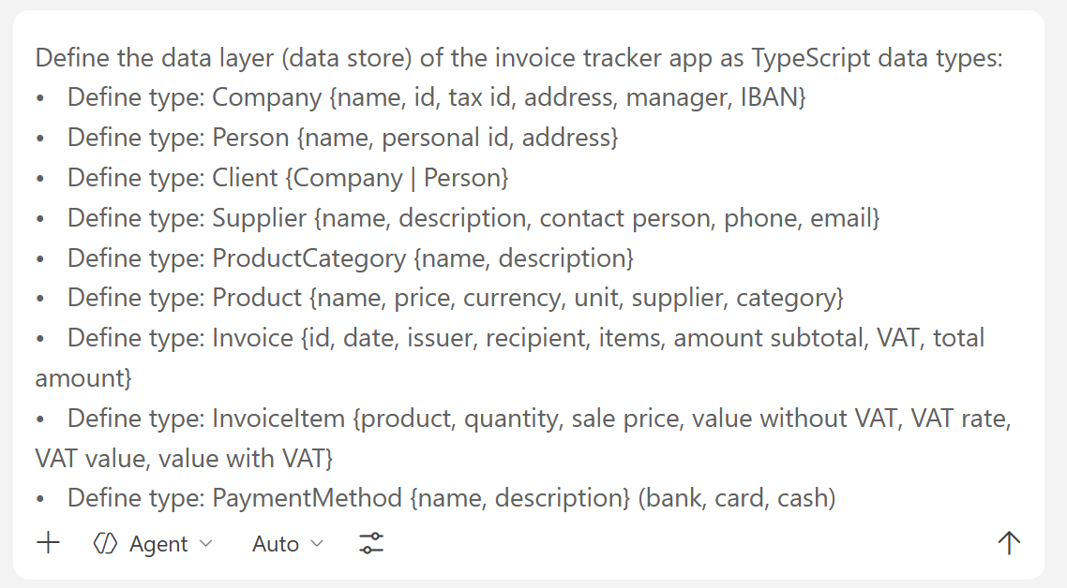

The App Data in the Code
You can find the data types in a new "data" folder in the following format:
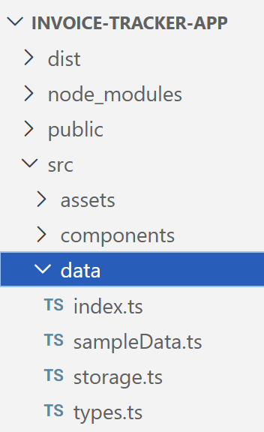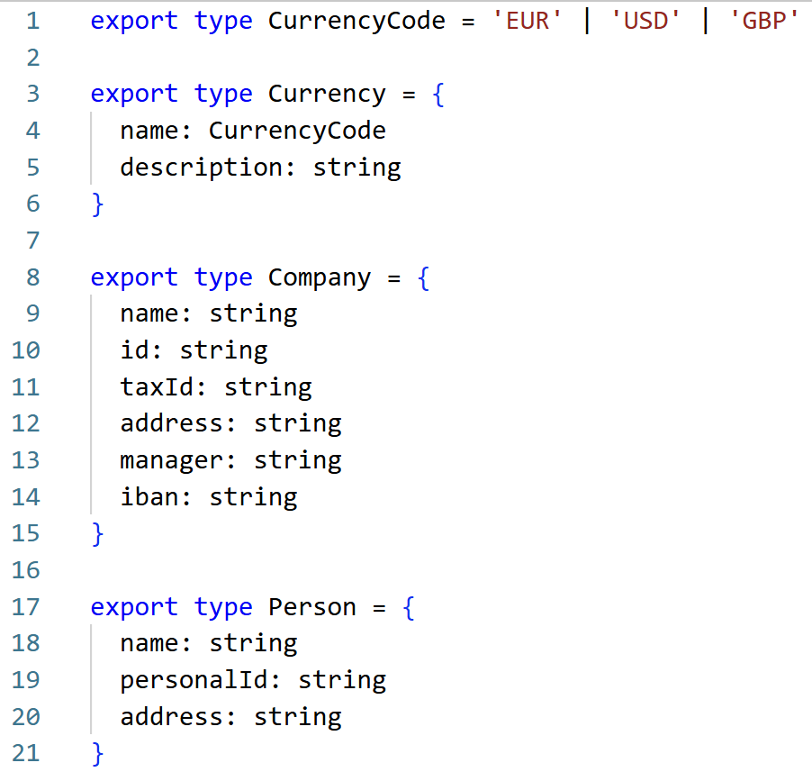

Step 3 - My Company Tab
Implement the tab "My Company", holding the company profile and app settings:
- Implement a section "Company Profile":
  - Display the company profile as a table: name, id, tax id, address, manager, ISBN.
  - Add [Edit] button. Implement an editor (modal popup) for the company profile data.
- Implement a section "App Settings":
  - Implement a field "Default VAT value" (in percents).
  - Implement a currencies editor (with add / edit / delete with confirm, with popups).
  - Implement a payment methods editor (with add / edit / delete with confirm, with popups).
- Implement the UI for the tab in a separate folder as React components.

The AI Prompt
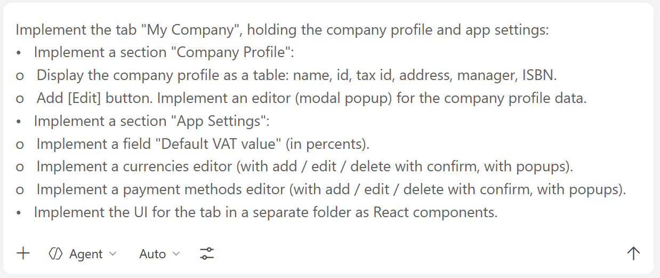

The Tab in the Browser

My Company Tab
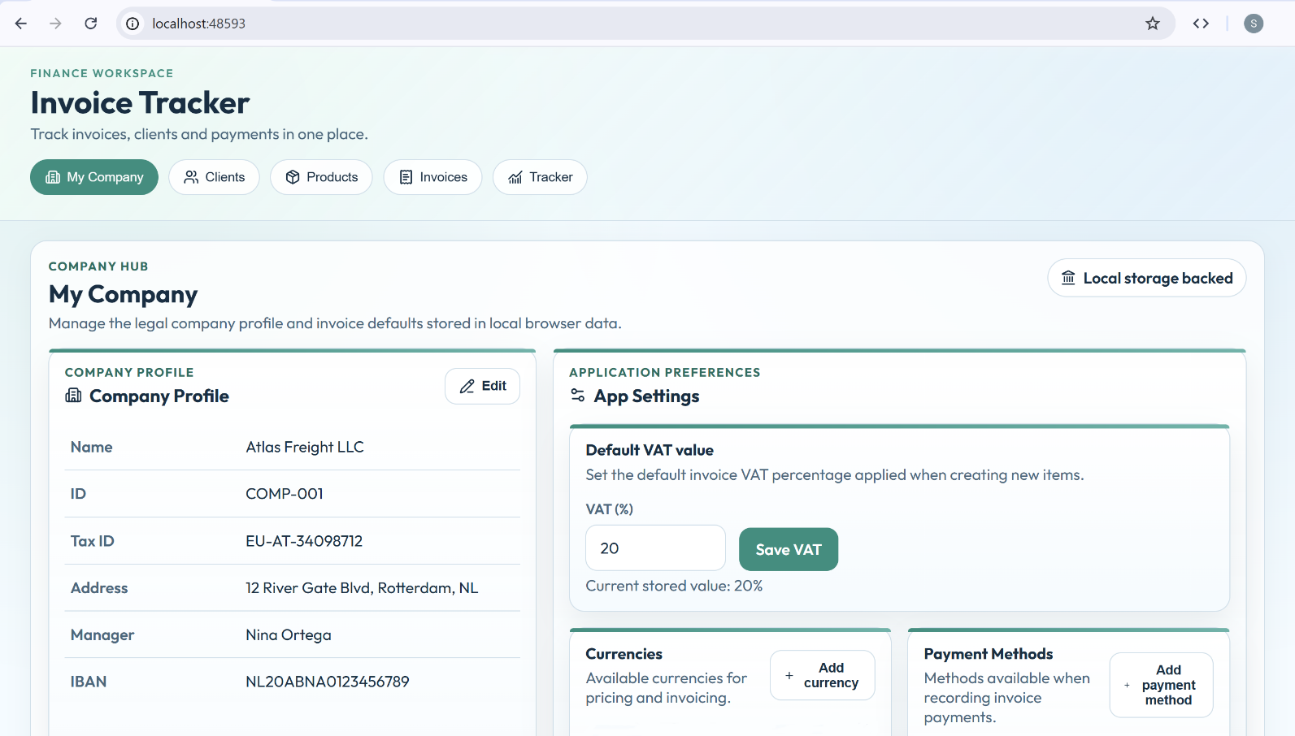

Company Details
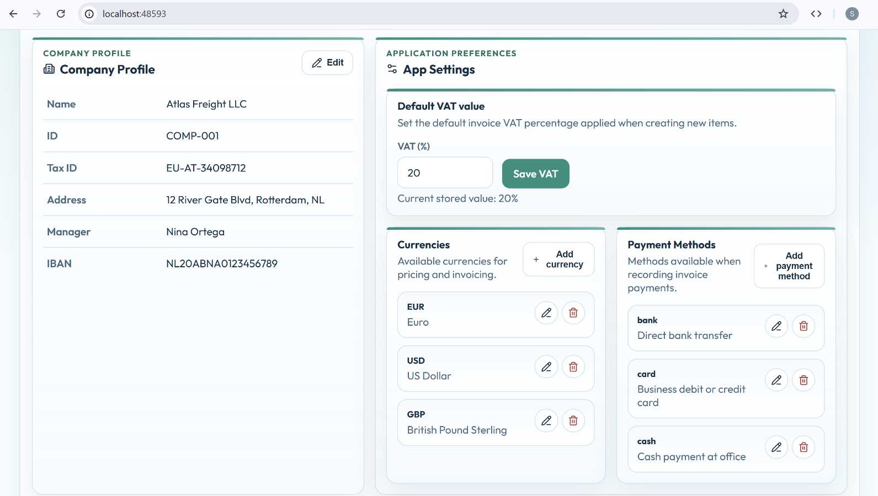

Popup Windows
Editing a company profile:
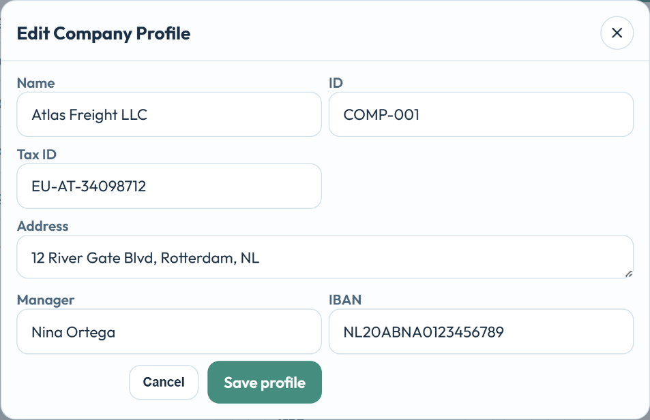
Adding a Payment Method:
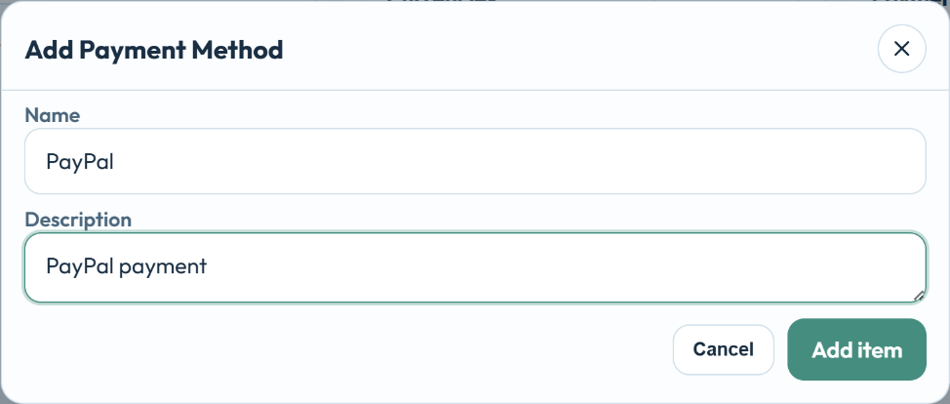

Step 4 - Clients Tab
Implement the "Clients" tab, holding the company clients (companies and physical people):
- Display the clients as a table, which mixes the companies and physical people.
- Add [Edit] and [Delete] buttons for each table row.
- Implement add / edit / delete confirm with popups.
- When add / edit a client, first choose a client type (company or person), then fill relevant client data.
- Implement the UI for the tab in a separate folder as React components.

The AI Prompt
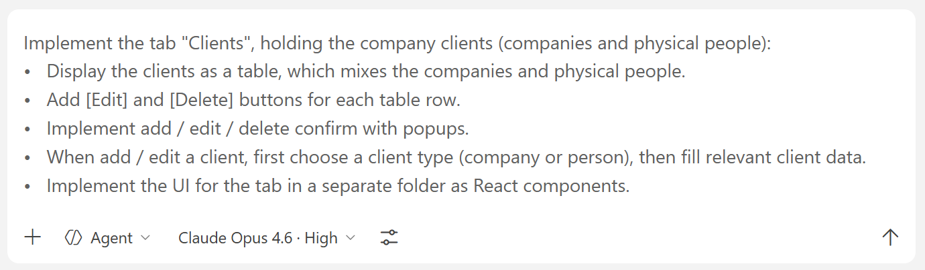

The Tab in the Browser
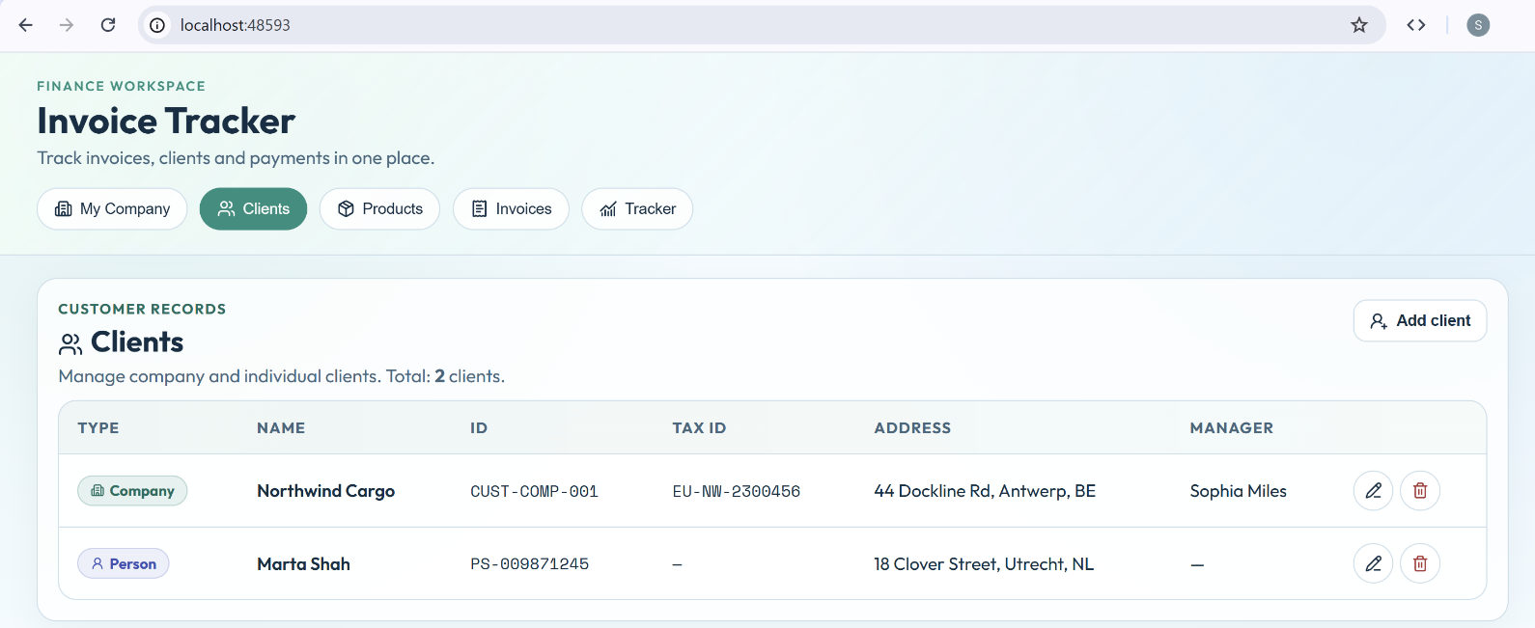

Choosing a Client Type
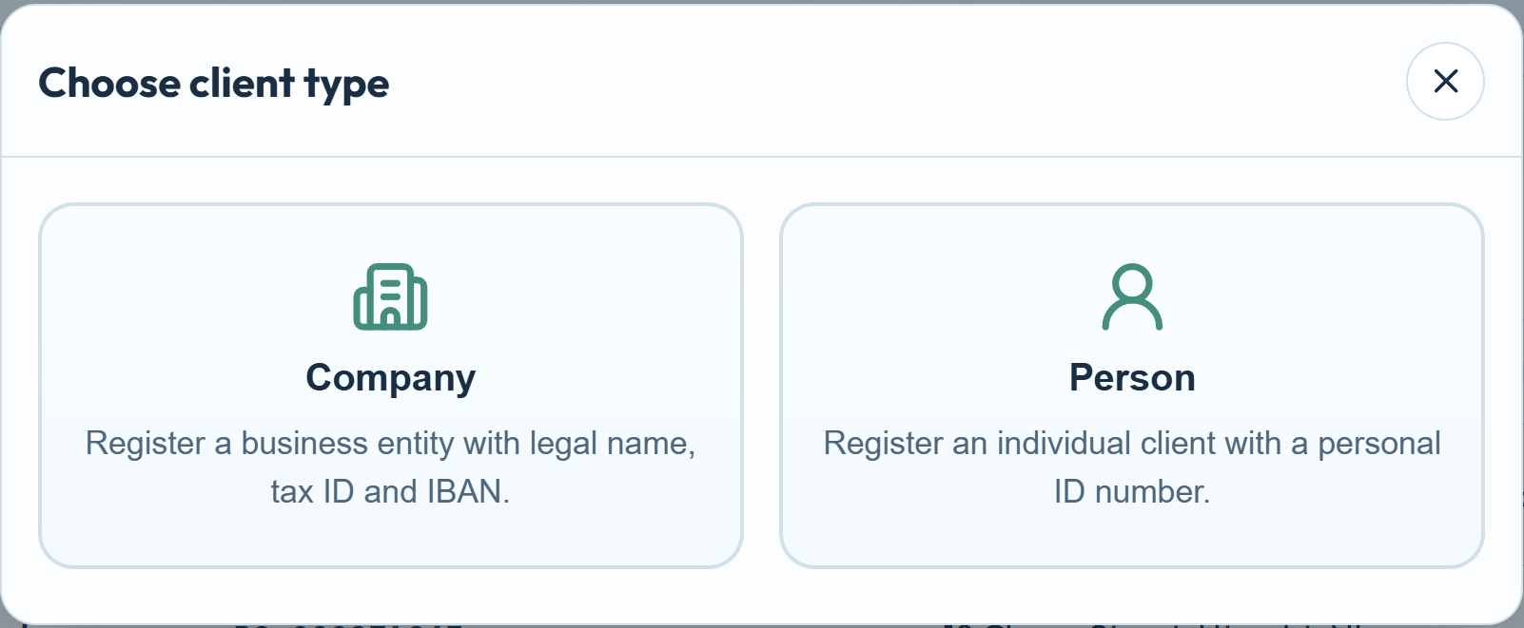

Adding a Company Client
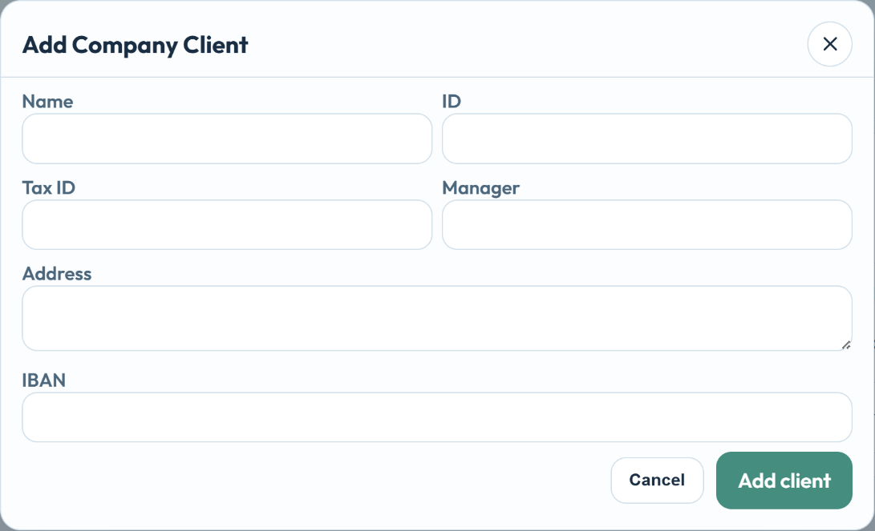

Editing a Person Client
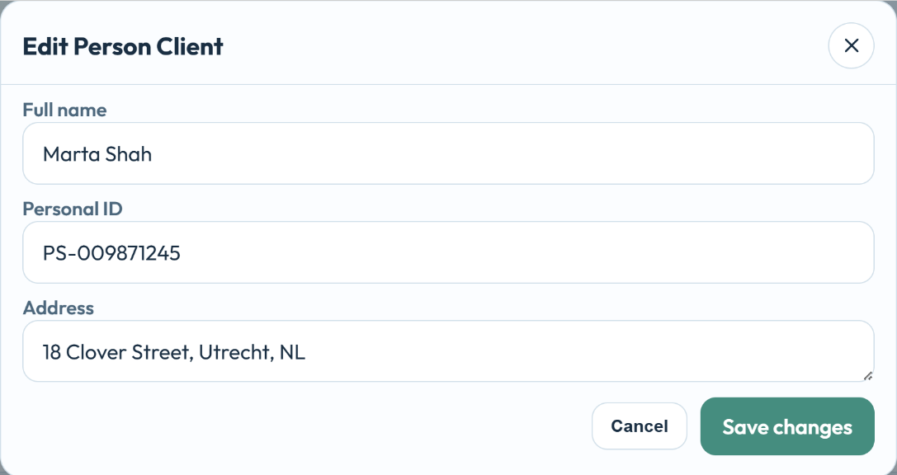

Step 5 - Products Tab
Implement the tab "Products" to list and edit products, categories and suppliers:
- Implement 3 tabs with navigation: Products | Categories | Suppliers.
- Products editor:
  - Display the products as a table.
  - Add [Edit] and [Delete] buttons for each table row.
  - Implement add / edit / delete confirm with popups.
  - Implement category selection as drop-down with search.
  - Implement supplier selection as modal popup listing the suppliers with search.
- Categories editor:
  - Display the product categories as a table.
  - Add [Edit] and [Delete] buttons for each table row.
  - Implement add / edit / delete confirm with popups.
- Suppliers editor:
  - Display the supplier categories as a table.
  - Add [Edit] and [Delete] buttons for each table row.
  - Implement add / edit / delete confirm with popups.
- Implement the UI for the tab in a separate folder as React components.

The AI Prompt
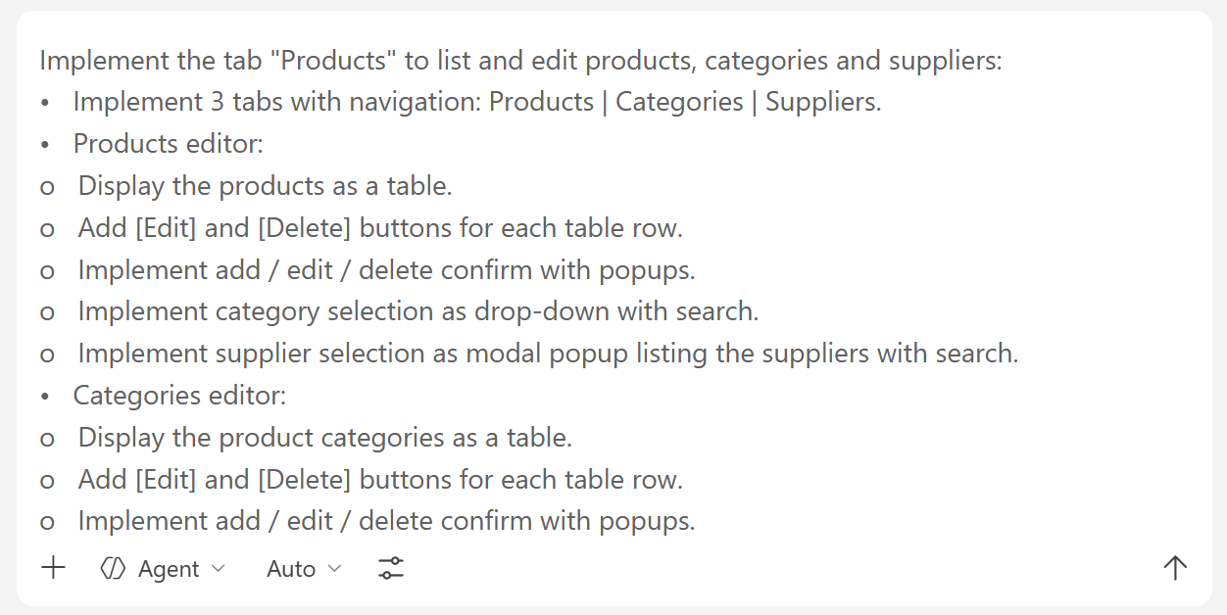

The Tab in the Browser
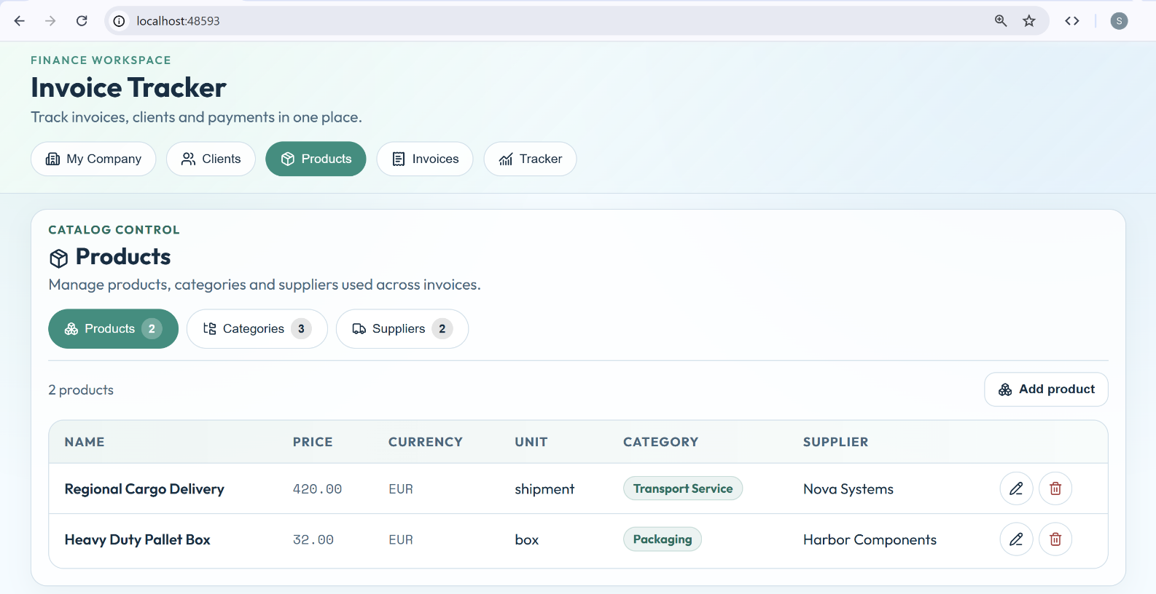

Popup Windows
Adding a Product:
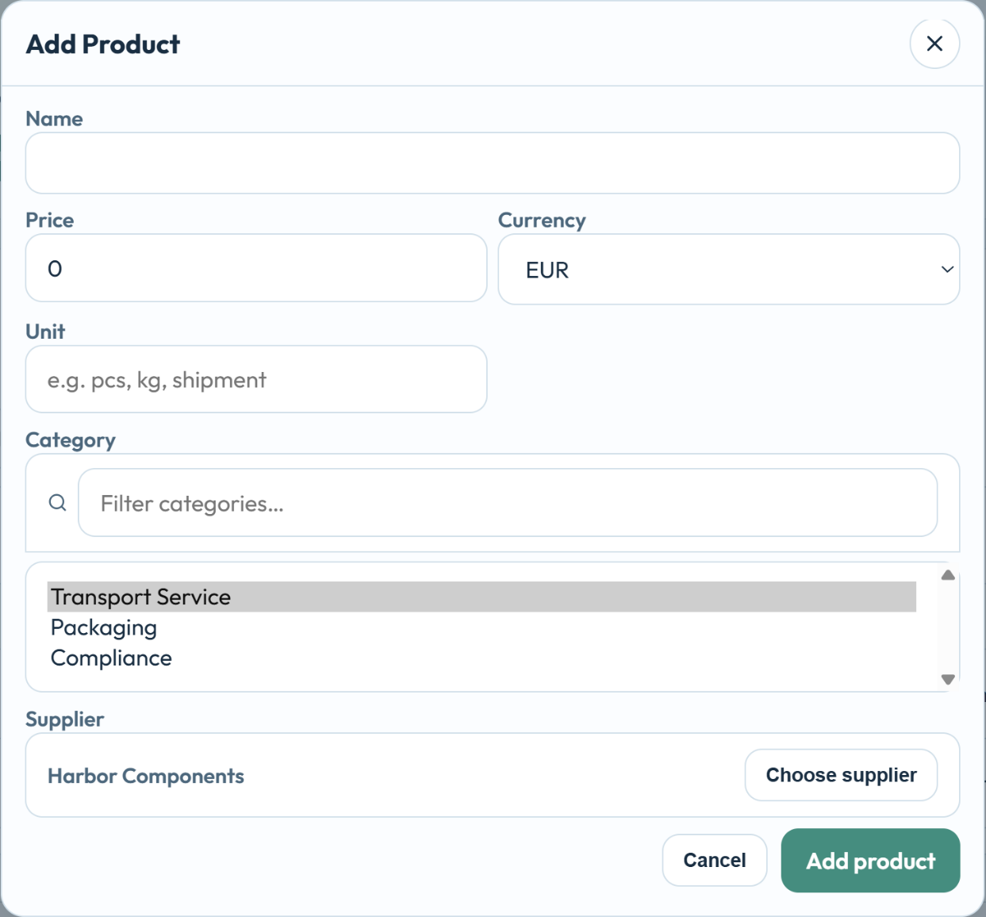
Editing Categories:
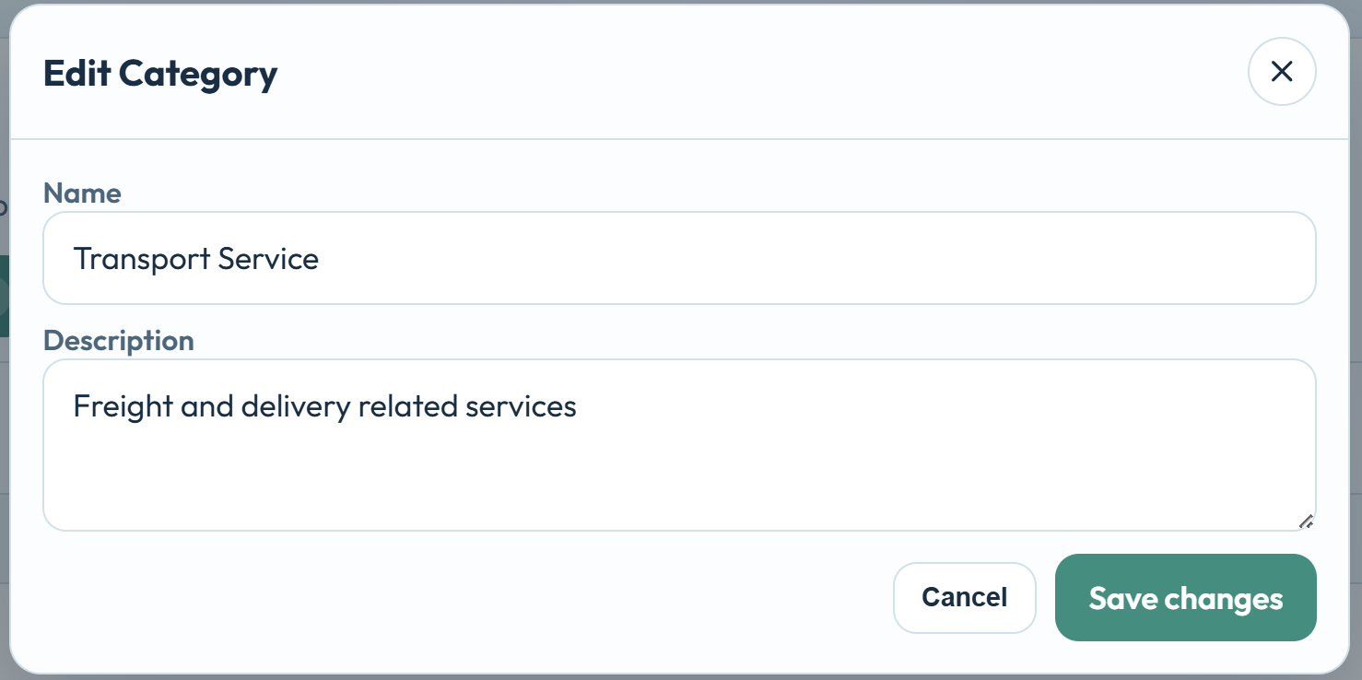

Step 6 - Invoices Tab
Implement the tab "Invoices" to list, view, add, edit, delete invoices:
- Display the invoices as a table.
- Implement [Edit] and [Delete] buttons for each table row.
- Implement [Add] button to add a new invoice.
- Implement view / add / edit / delete invoice (with confirm) with popups.
- Implement an invoice editor as separate React component.
- Implement the client selection as modal popup listing the clients (with search).
- Implement the invoice items editor as table (visible in the invoice editor).
  - Implement add / edit / delete (as buttons in the table).
  - Implement the product selection as modal popup listing the products (with search).
- Implement the UI for the tab in a separate folder as React components.

The AI Prompt
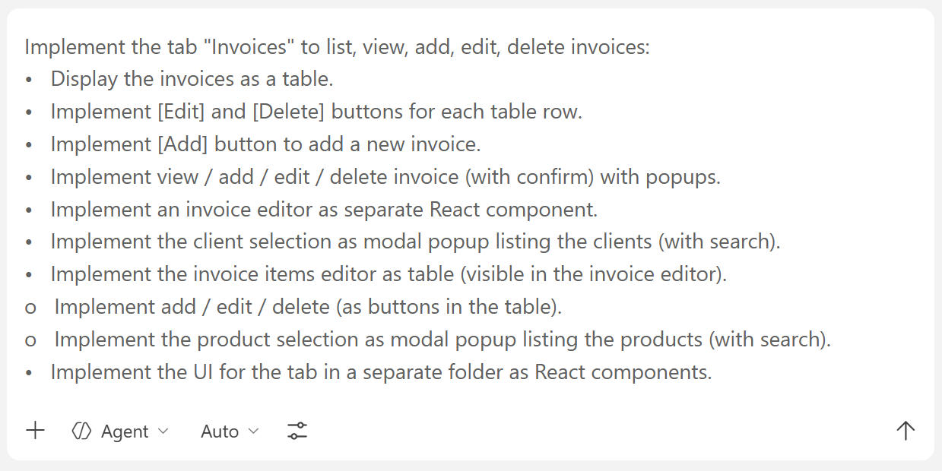

The Tab in the Browser
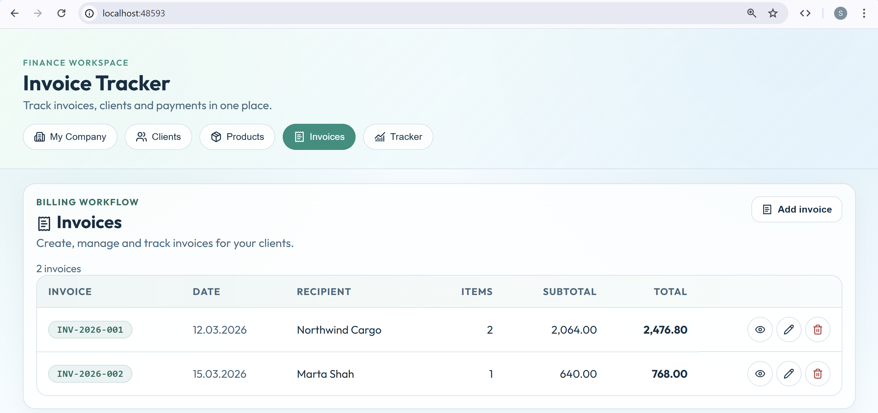

Sample Invoice
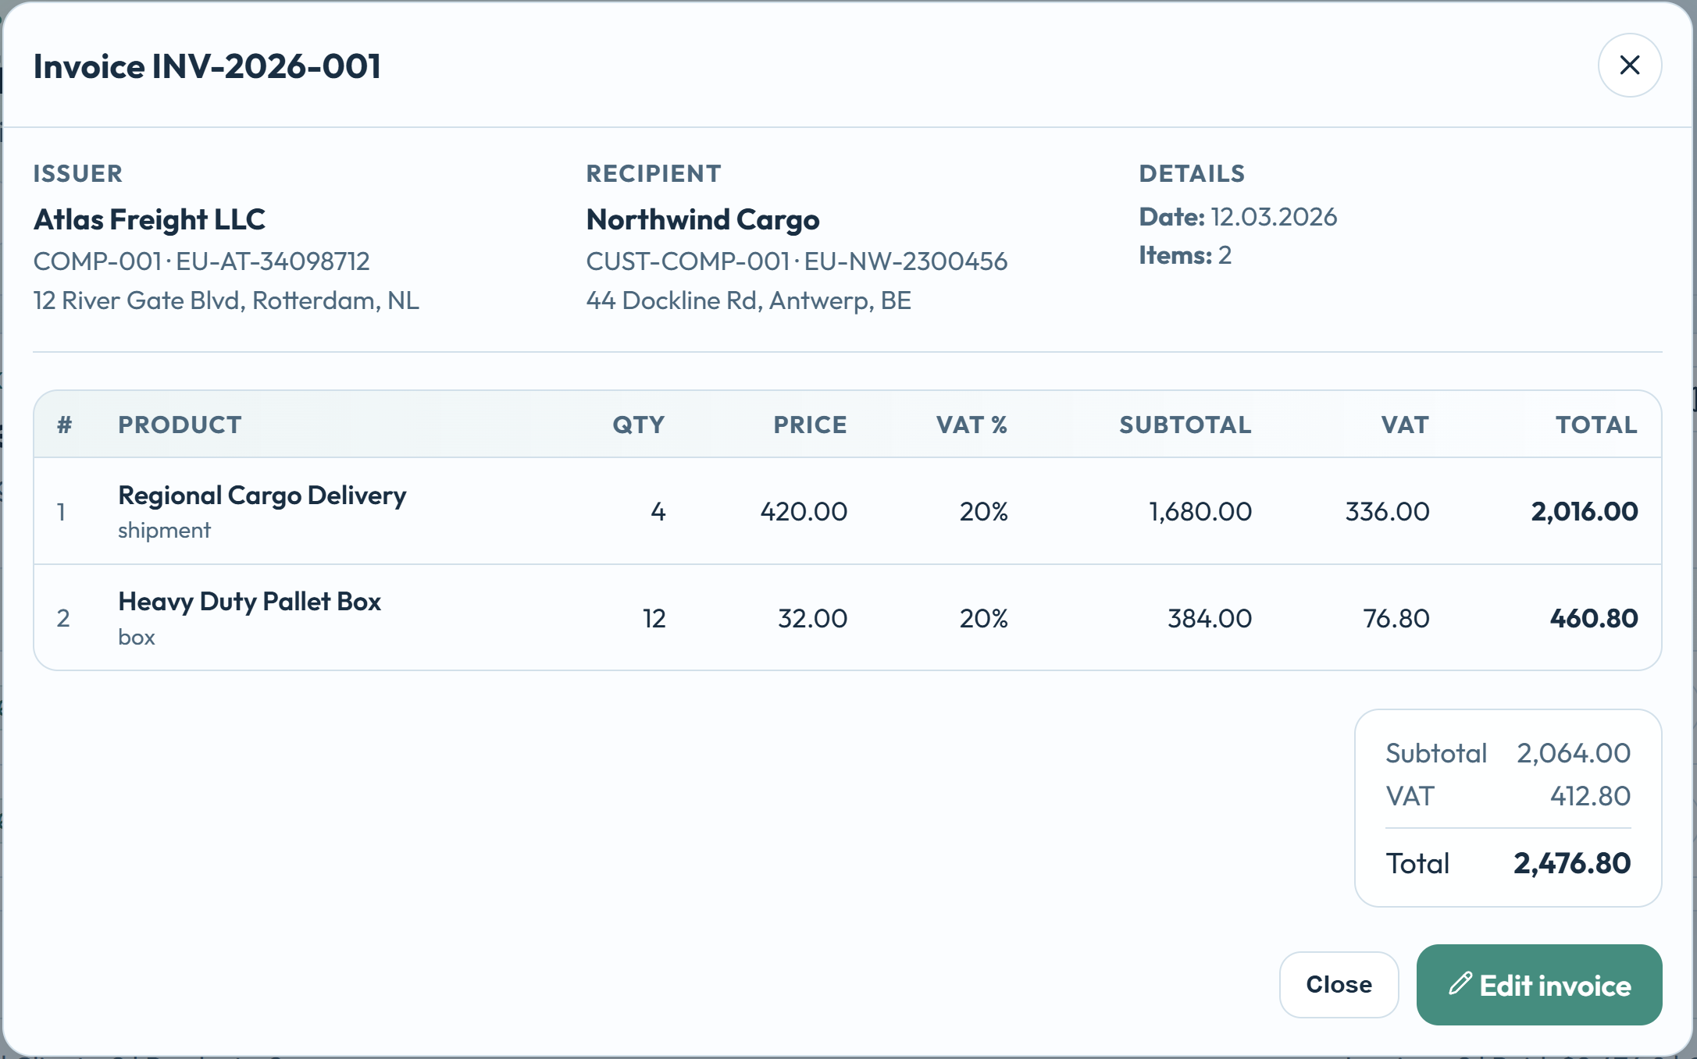

Adding an Invoice
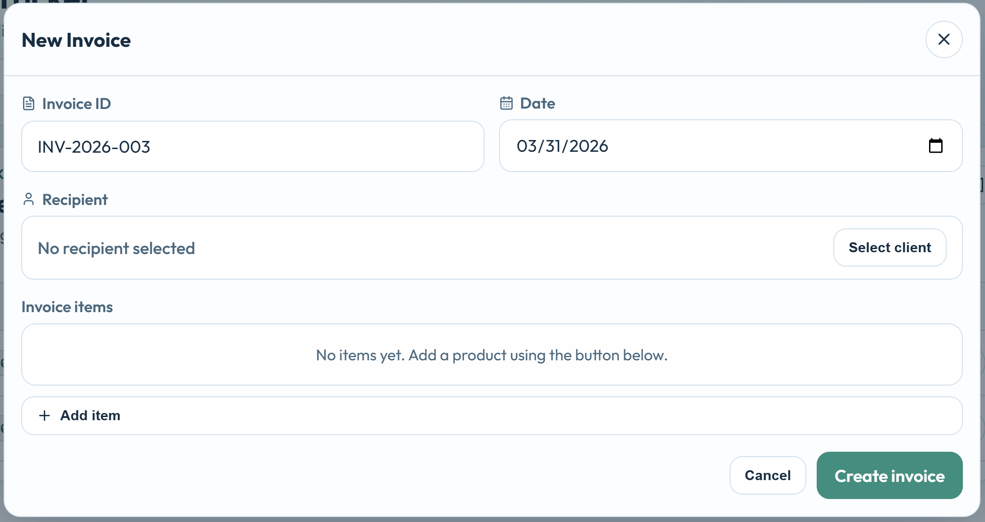

Step 7 - Tracker Tab
Implement the tab "Tracker", to track the invoice payments:
- Display the invoices, mixed with invoice payments as a table, with search.
  - Display basic invoice data + paid / unpaid + date of payment + payment method.
- Implement buttons [Mark as Paid] / [Mark as Unpaid].
  - When an invoice is marked as paid, choose a date of payment (calendar) and the payment method (drop-down). Use a modal popup.
  - When an invoice is marked as unpaid, display a conformation with a modal popup.
- Implement the UI for the tab in a separate folder as React components.

The AI Prompt
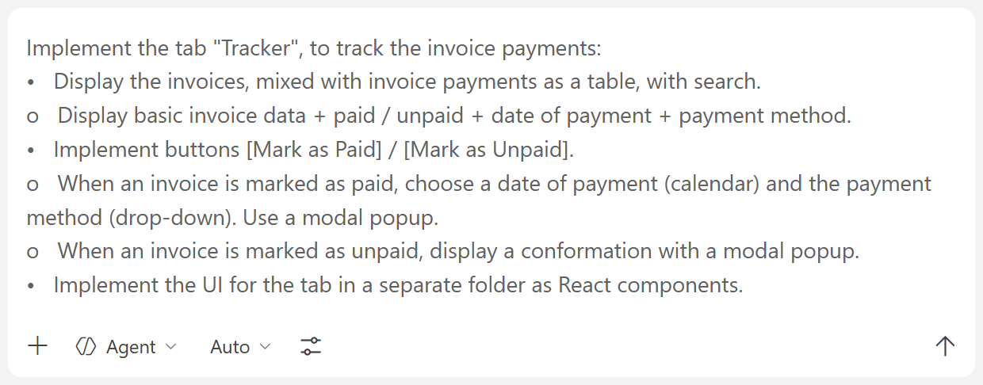

The Tab in the Browser
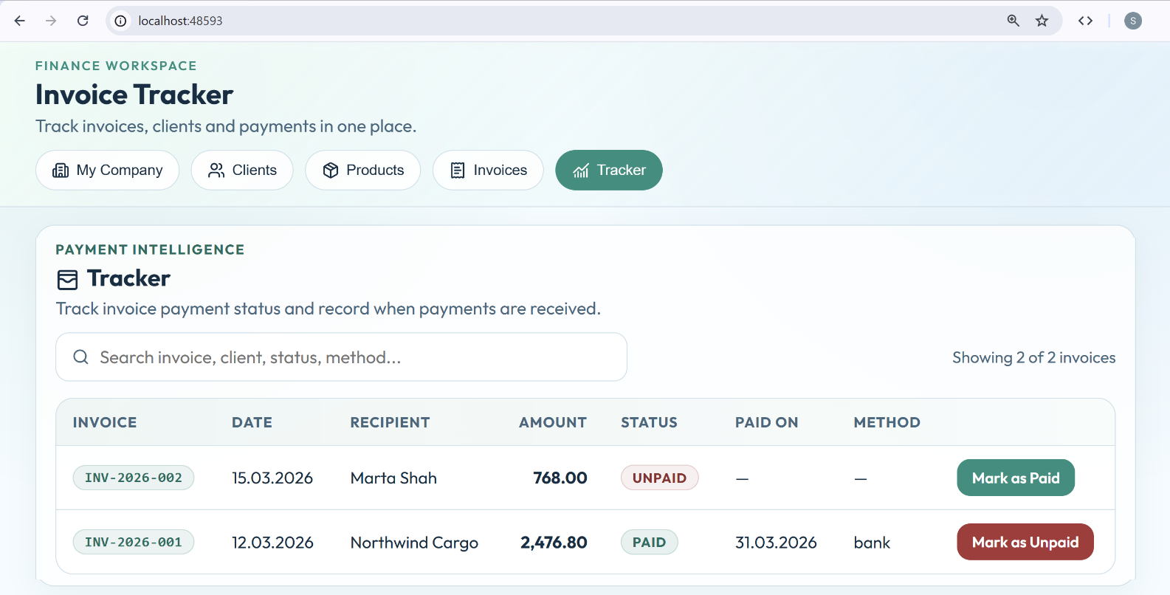

Event Tracker App*
Your goal is to create an "Event Tracker" app (based on React), which will manage and track events, attendees, venues and ticket payments.
The app should allow creating events, assigning attendees, issuing tickets and tracking payments.

Step 1 - VS Code Project

Create Workspace
Create an empty VS Code workspace.

React App with TypeScript
Create an empty React + TypeScript + Vite app.
- Implement modern, responsive UI
- Use icons, animations and toast notifications
- Split the UI into modular React components

App Layout
Implement the app layout, the main app screens and navigation:
- Implement app layout with header + footer + content.
- In the app header implement tabs navigation.
- Implement several tabs (initially empty), which will hold the different screens of the app:
  - Events
  - Attendees
  - Venues
  - Tickets
  - Tracker
- Keep the code for each tab in a separate React component:
  - EventsEditor
  - AttendeesEditor
  - VenuesEditor
  - TicketsEditor
  - Tracker
- Use a full-width layout to render tabs content.

The AI Prompt
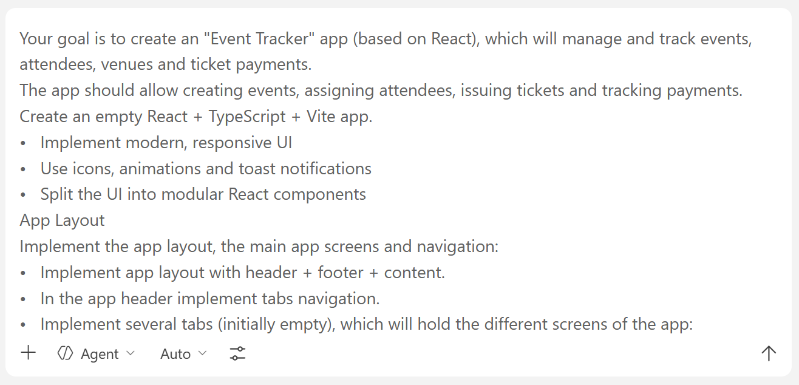

The App in the Browser
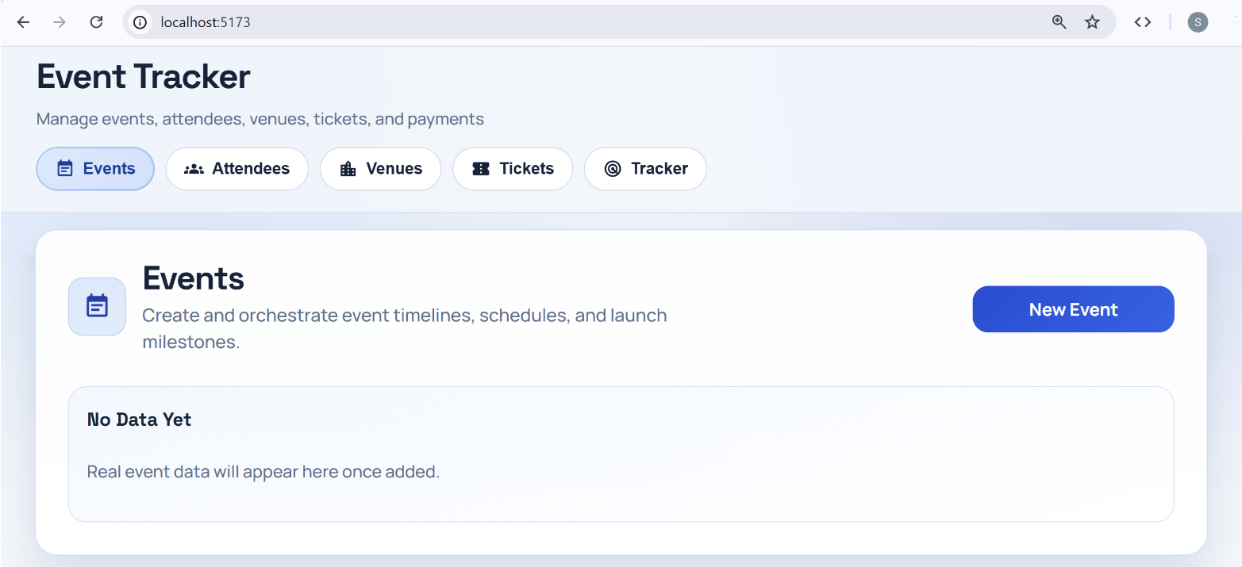

Step 2 - App Data
Define the data layer (data store) of the event tracker app as TypeScript data types:
- Define type: Event {id, name, date, venue, description}
- Define type: Attendee {id, name, email, phone}
- Define type: Venue {id, name, address, capacity}
- Define type: Ticket {id, event, attendee, price, status}
- Define type: PaymentMethod {name, description} (bank, card, cash)
- Define type: TicketPayment {ticket, datePaid, paymentMethod}
- Define type: Currency {name, description} (EUR, USD, GBP)
- Define type: AppSettings {defaultCurrency}
- Keep code for the data layer in a separate folder "data".
- Keep all app data in the browser's local storage (no database yet): events, attendees, venues, tickets, paymentMethods, ticketPayments, appSettings, etc.
- Initially, generate sample data, so that the app will not be empty at the start.

The AI Prompt
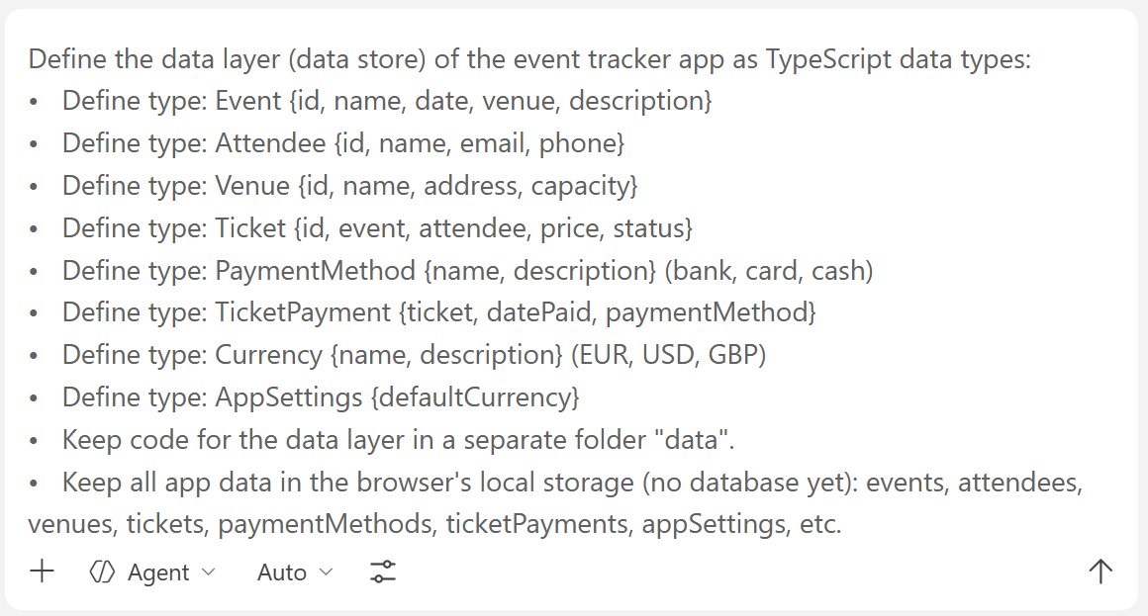

The App Code
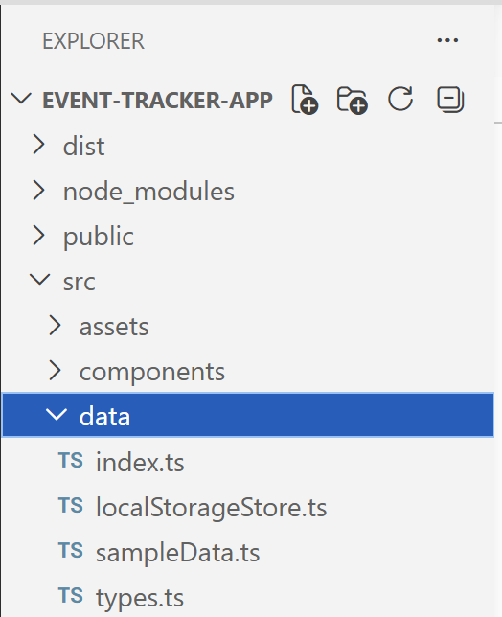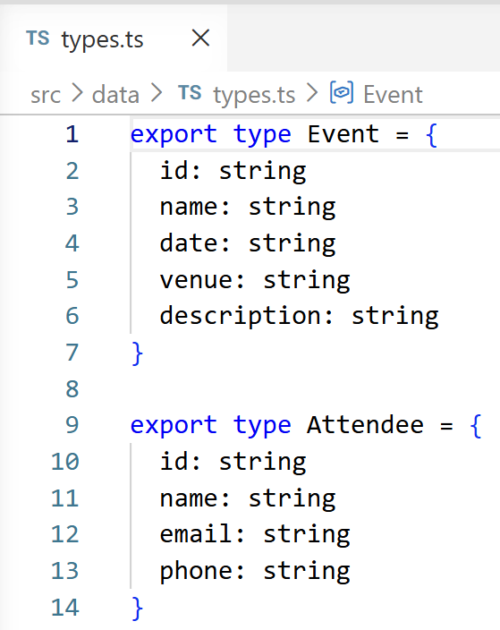

Step 3 - Events Tab
Implement the tab "Events", holding the events:
- Display the events as a table: name, date, venue, description.
- Add [Edit] and [Delete] buttons for each table row.
- Implement add / edit / delete confirm with popups.
Implement Event Editor:
- Implement an event editor as modal popup.
- Fields: name, date, venue, description.
Implement Venue Selection:
- Implement venue selection as modal popup listing the venues (with search).
Implement Event Statistics:
- Display for each event:
  - number of attendees (based on tickets count)
  - total revenue (sum of ticket prices)
- These values should be calculated dynamically.

The AI Prompt
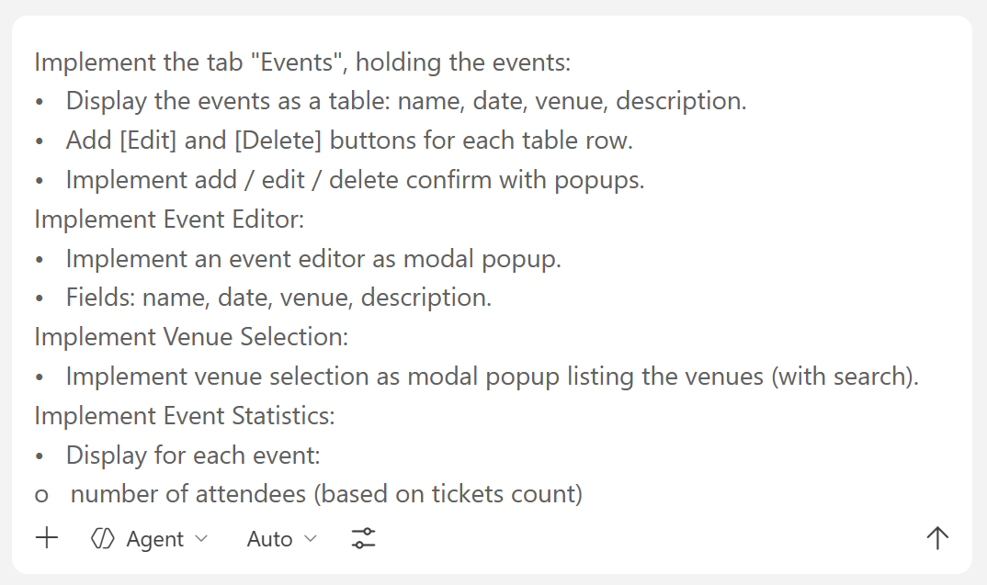

The Events Tab
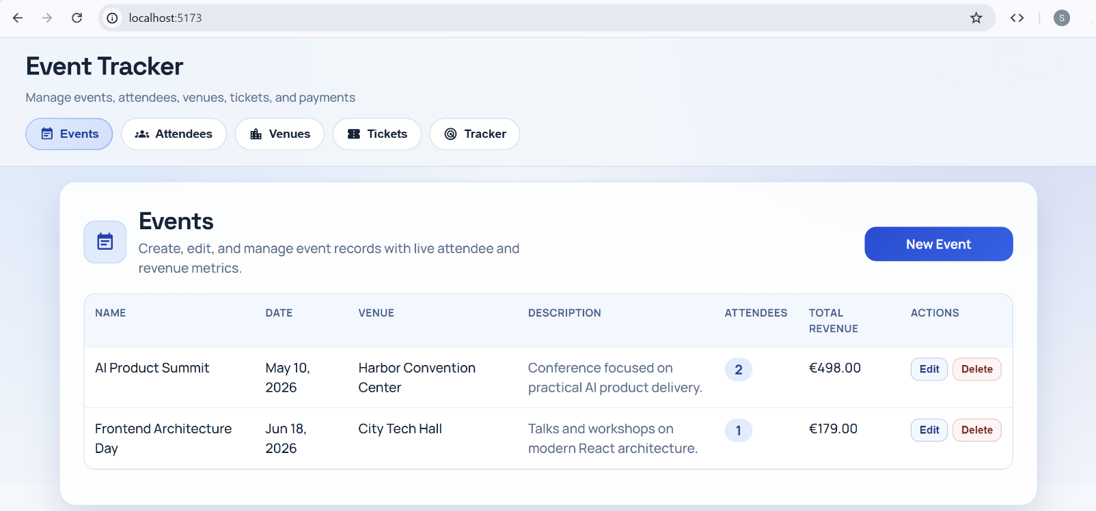

The Popup Windows
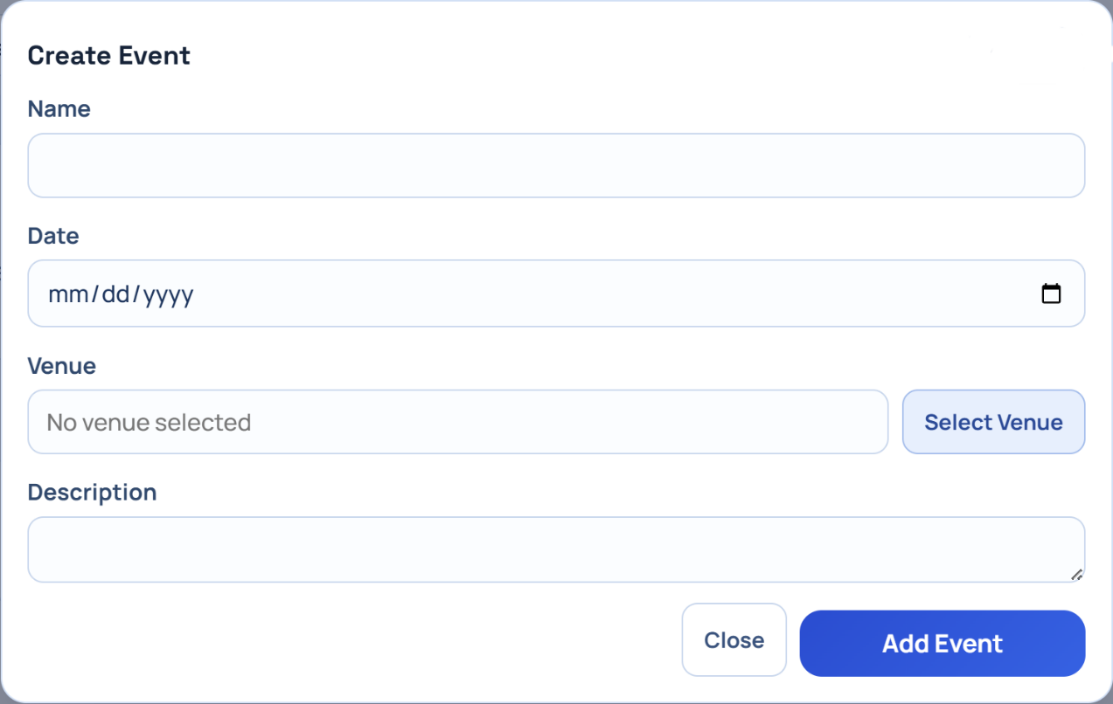

Step 4 - Attendees Tab
Implement the tab "Attendees", holding the event attendees:
- Display the attendees as a table.
- Add [Edit] and [Delete] buttons for each table row.
- Implement add / edit / delete confirm with popups.
Implement Attendee Editor:
- Implement add / edit attendee with modal popup.
- Fields: name, email, phone.

The AI Prompt
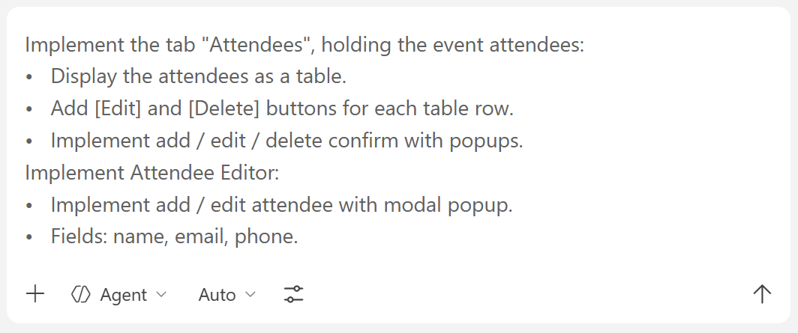

The Attendees Tab

General Overview
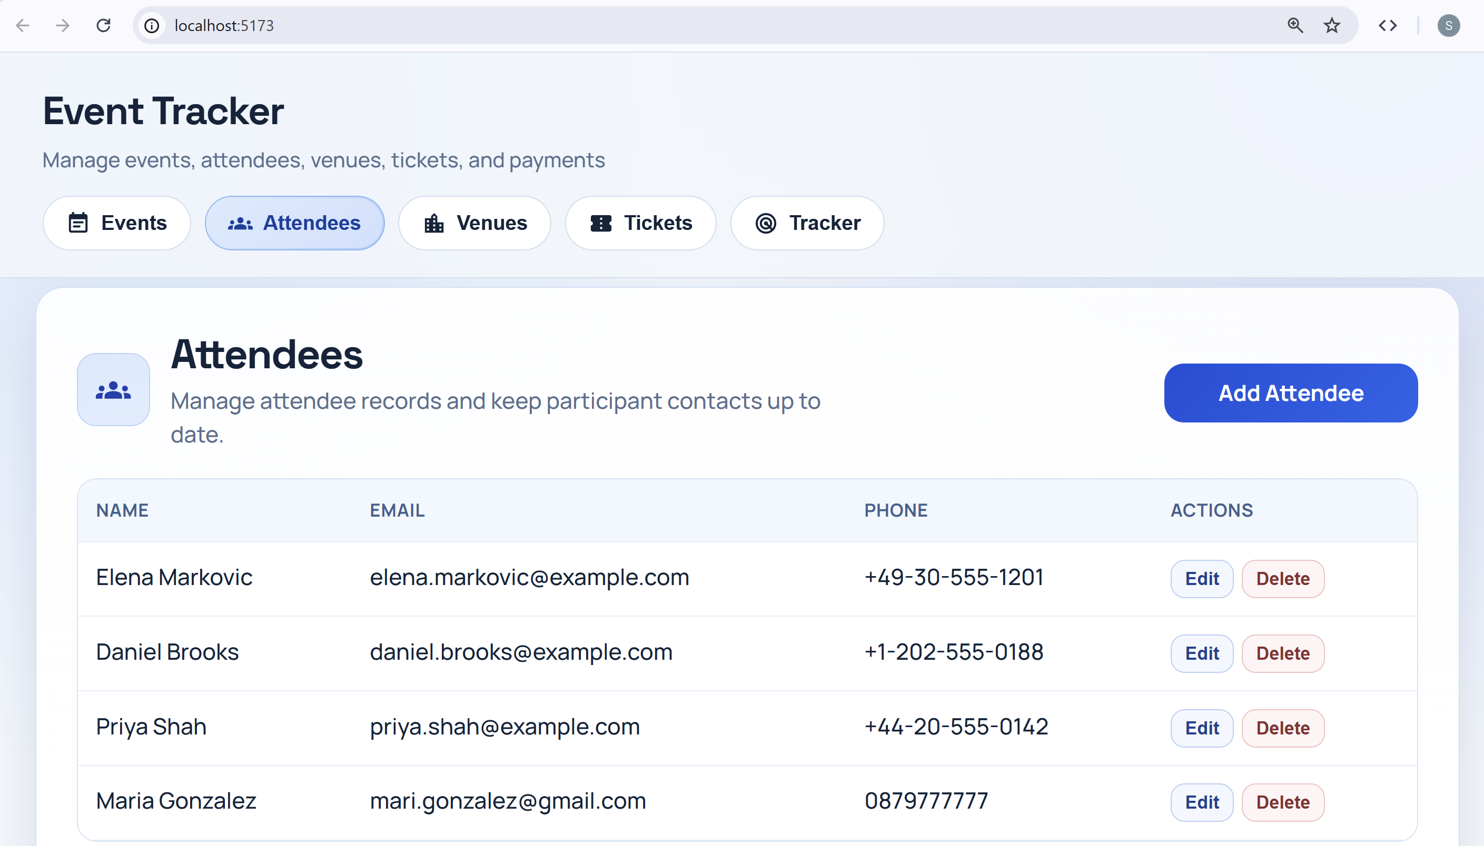

The Popup Windows
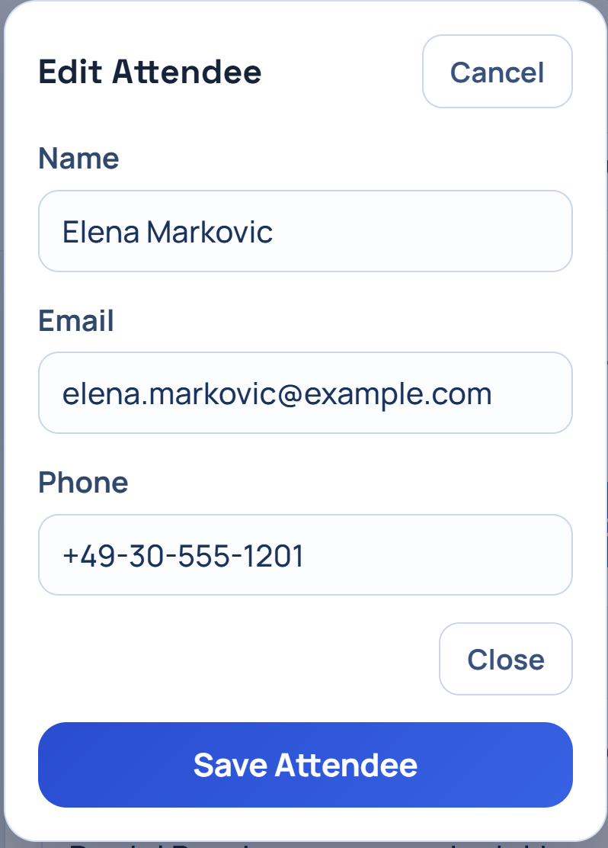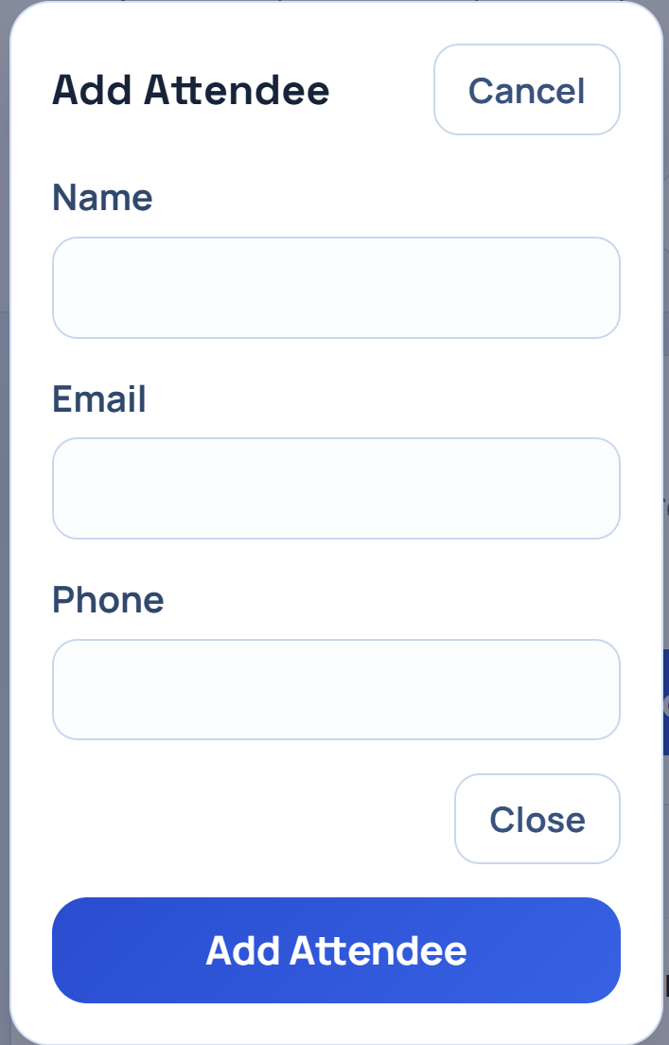

Step 5 - Venues Tab
Implement the tab "Venues", holding the event venues:
- Display the venues as a table.
- Add [Edit] and [Delete] buttons for each table row.
- Implement add / edit / delete confirm with popups.
Implement Venue Editor:
- Implement add / edit venue with modal popup.
- Fields: name, address, capacity.

The AI Prompt
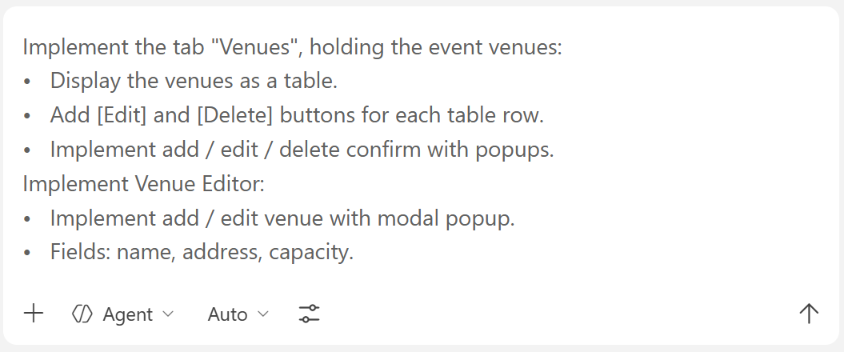

The Venues Tab
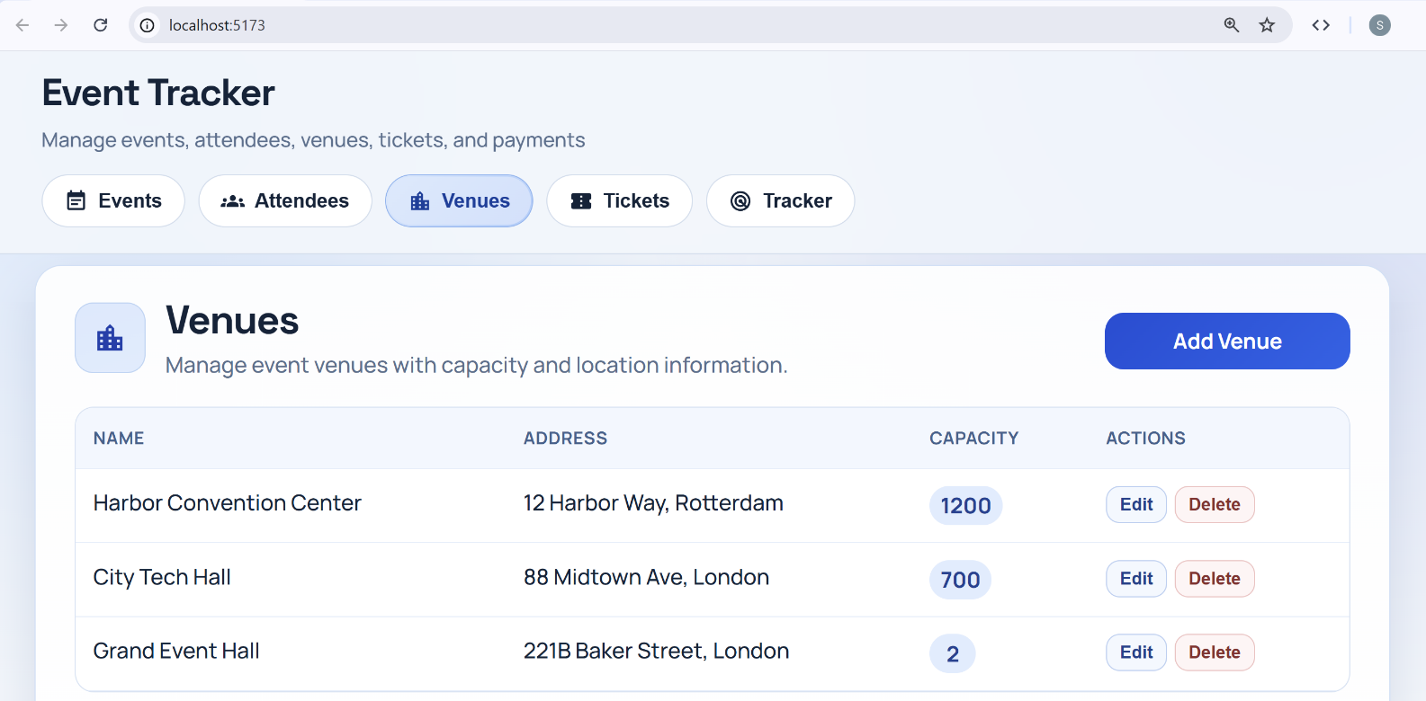

Step 6 - Tickets Tab
Implement the tab "Tickets" to list and edit tickets:
- Display the tickets as a table.
- Add [Edit] and [Delete] buttons for each table row.
- Implement add / edit / delete confirm with popups.
Implement a Ticket Editor:
- Implement ticket editor as modal popup.
- Implement event selection as dropdown or modal popup (with search).
- Implement attendee selection as modal popup (with search).
- Fields: event, attendee, price, status.
Implement Venue Capacity Constraint:
- When creating a ticket, check how many tickets already exist for the selected event.
- Get the venue capacity for that event.
- Do not allow adding more tickets than the venue capacity.
- Disable the add button or display an error message when the limit is reached.

The AI Prompt
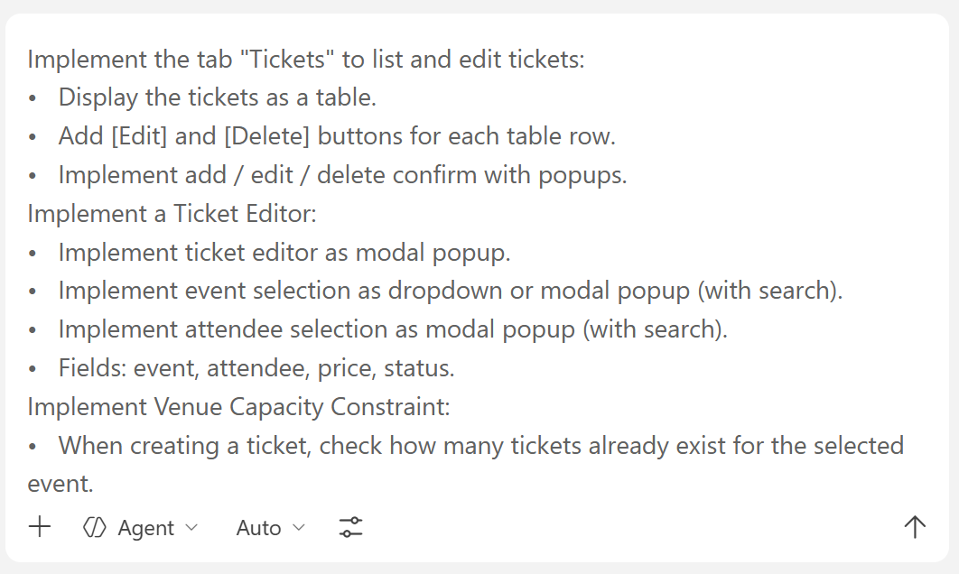

The Tickets Tab

General Overview
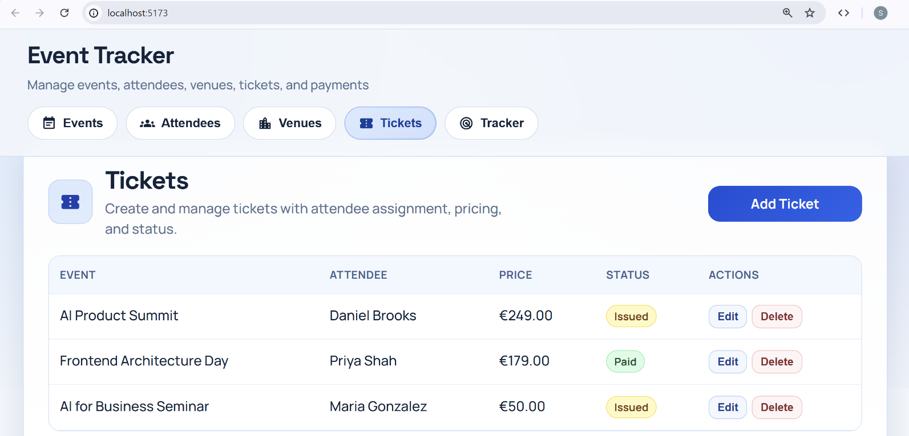

The Popup Windows
Before the Venue capacity is filled, the venue is clickable and can be chosen:
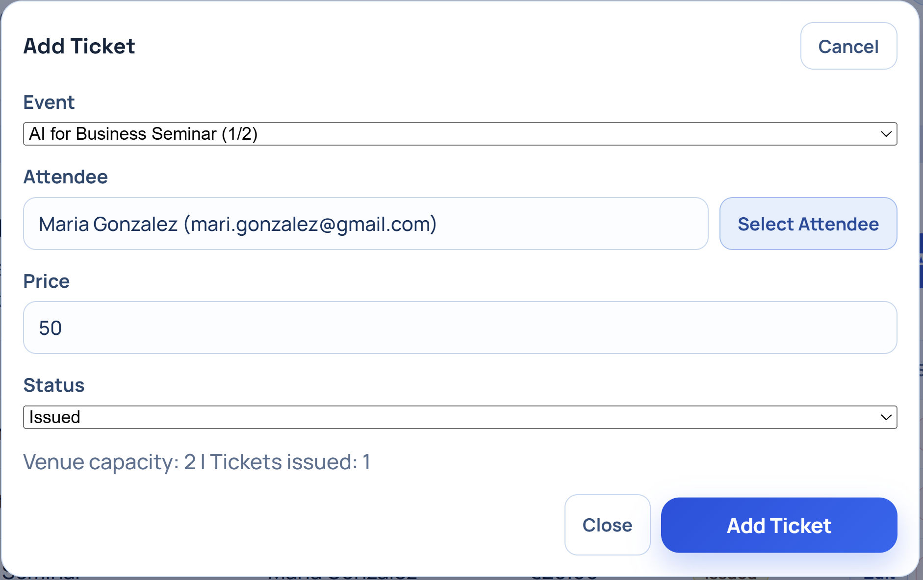
After the venue capacity is filled, tickets for the event in this venue can no longer be added:
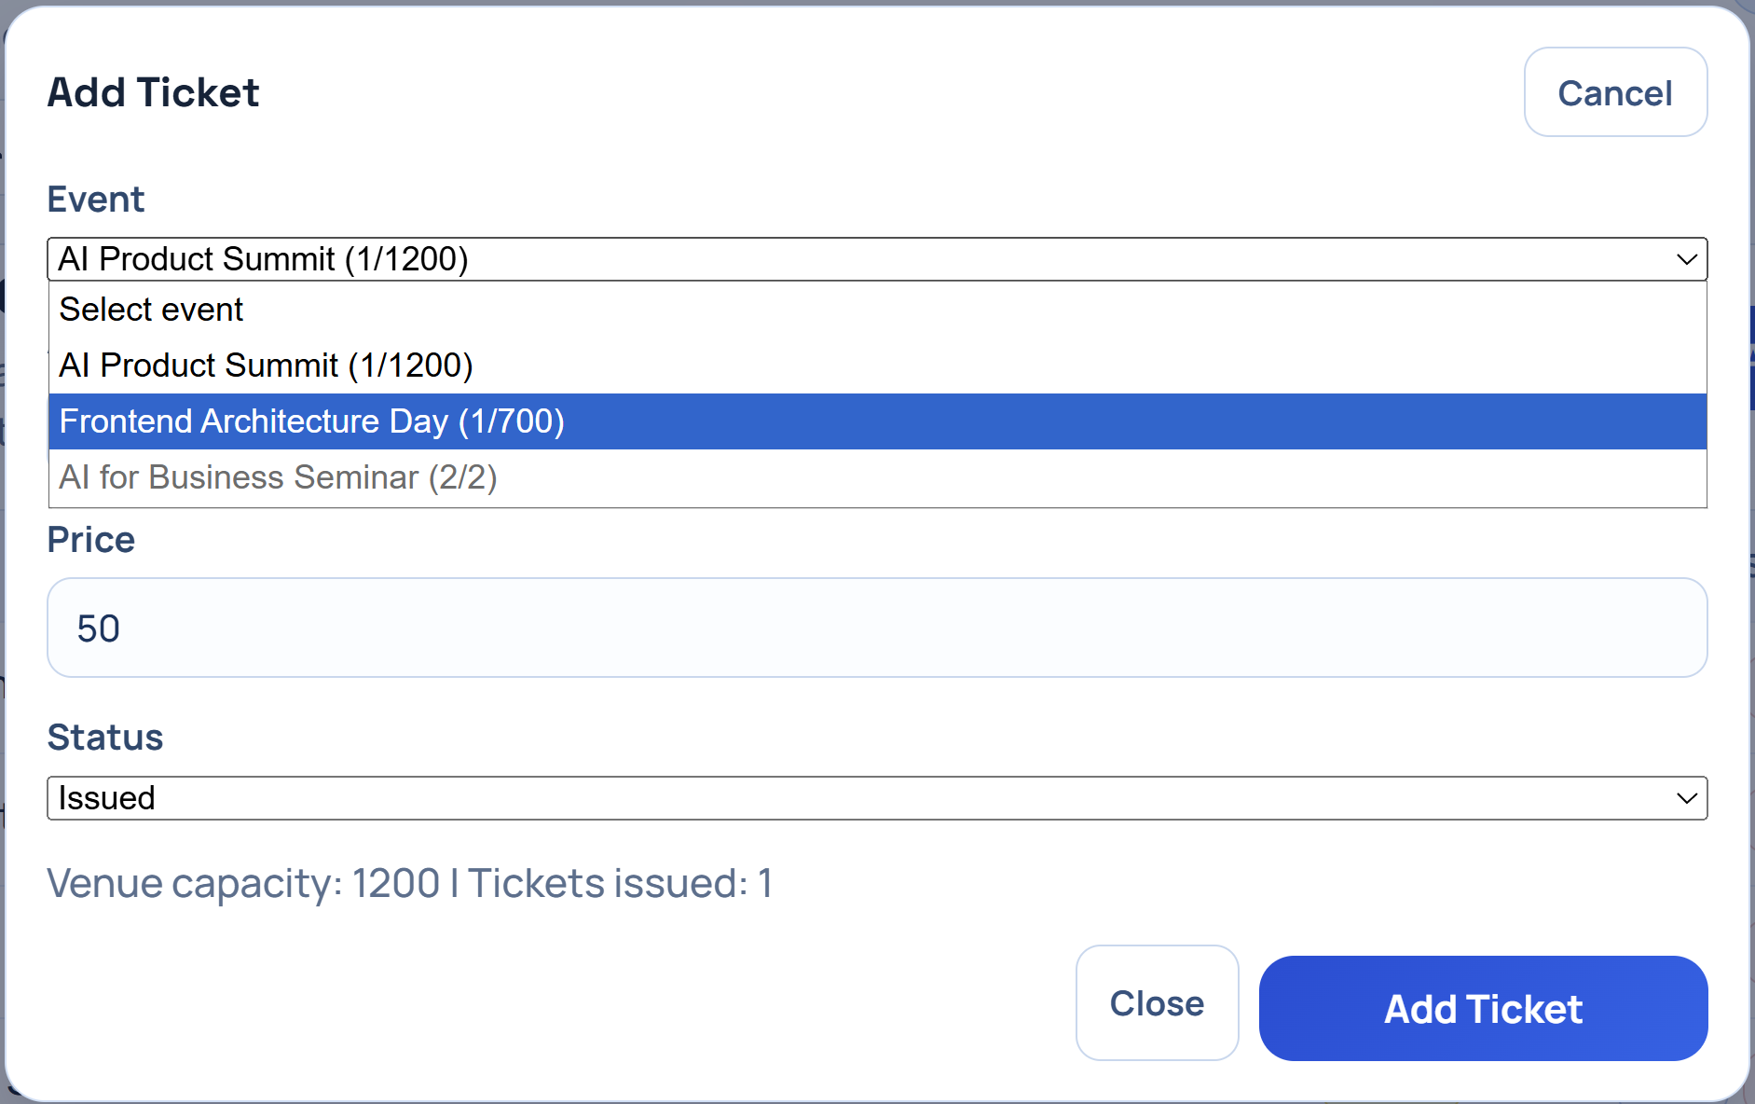

Step 7 - Tracker Tab
Implement the tab "Tracker", to track the ticket payments:
- Display the tickets, mixed with ticket payments as a table, with search.
- Display basic ticket data + paid / unpaid + date of payment + payment method.
Implement Actions: Buttons [Mark as Paid] / [Mark as Unpaid].
Implement a [Mark as Paid] button:
- When a ticket is marked as paid, choose a date of payment (calendar) and the payment method (drop-down). Use a modal popup.
Implement a [Mark as Unpaid] button:
- When a ticket is marked as unpaid, display a confirmation with a modal popup.
Implement Additional Requirements:
- Use popup dialogs to implement add / edit / confirm delete operations.
- Implement search filters in selection popups.
- Split the UI into modular React components.
Secure data consistency:
- When deleting an entity, assign undefined to all its dependent entities.
  - For example: If a venue is deleted, leave the event with no venue. If an attendee is deleted, leave the ticket with no attendee

The AI Prompt
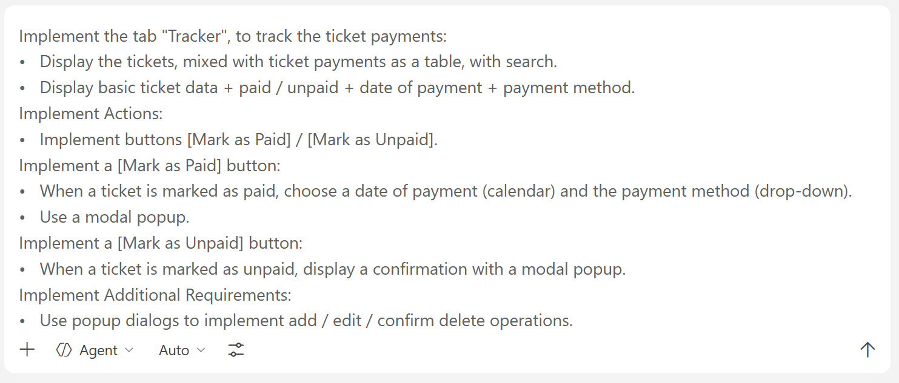

The Tracker Tab

General Overview
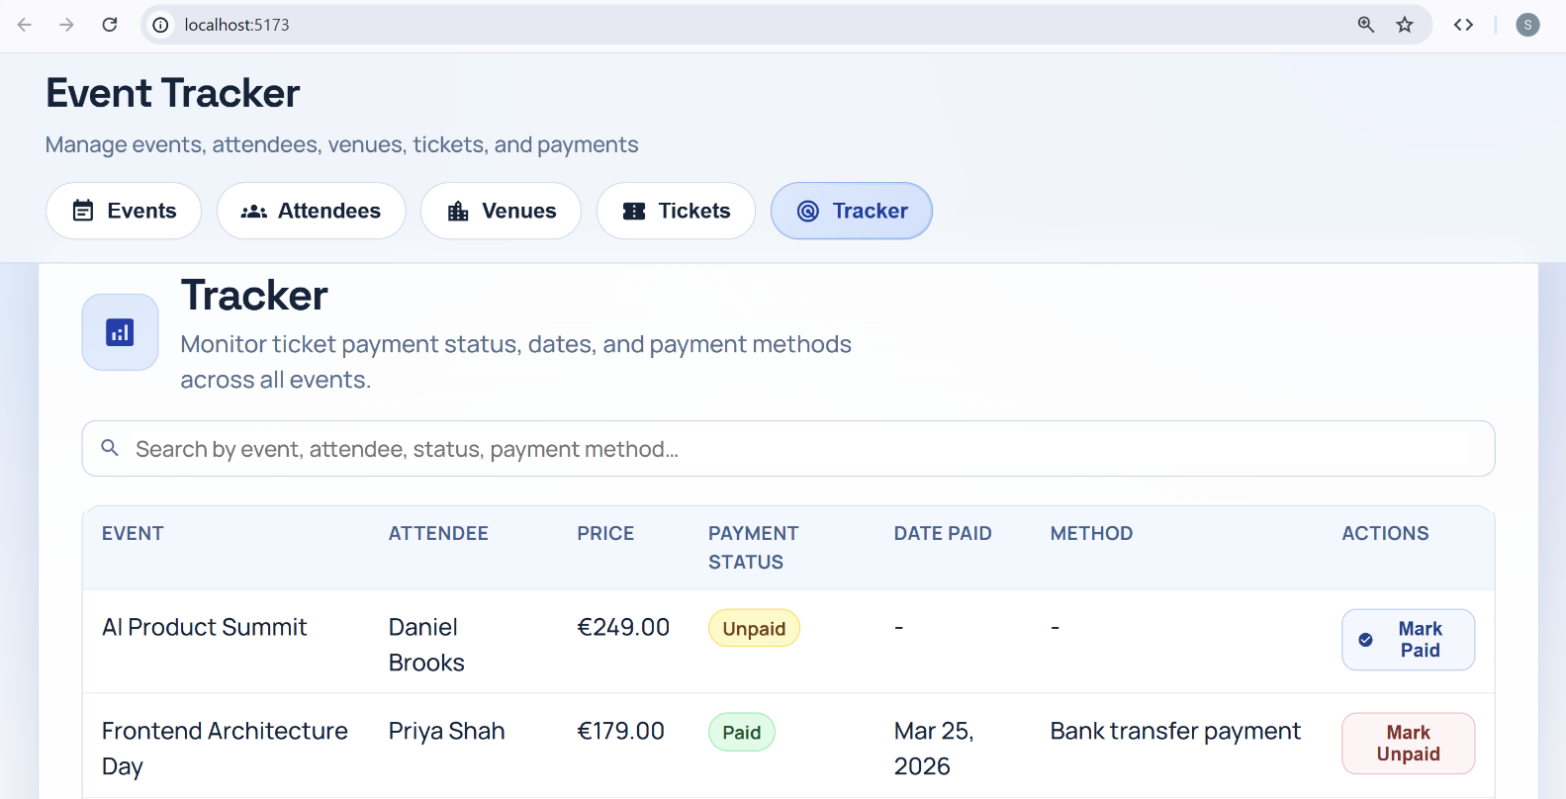

The Search Bar
Searching by event name:
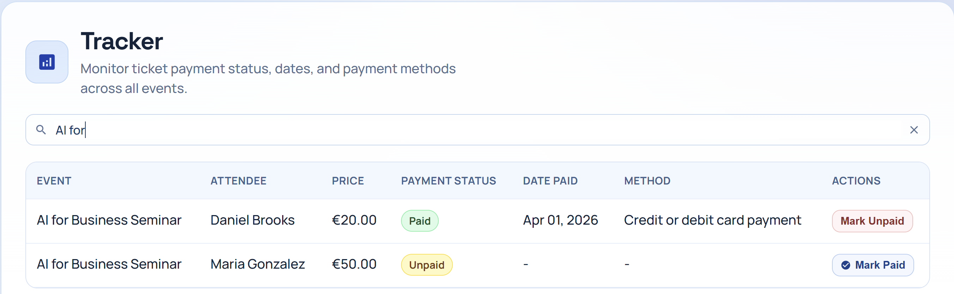
Searching by attendee name:
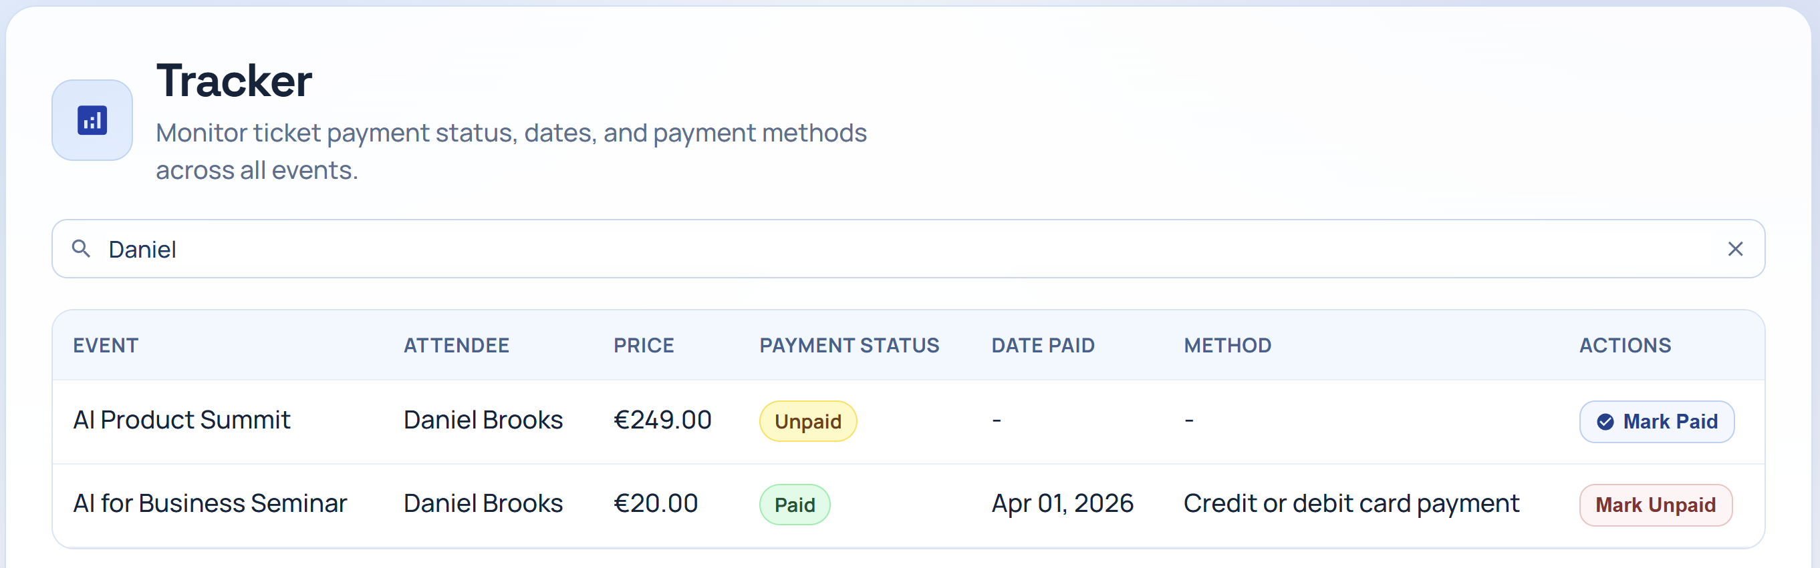

The Payment Confirmation
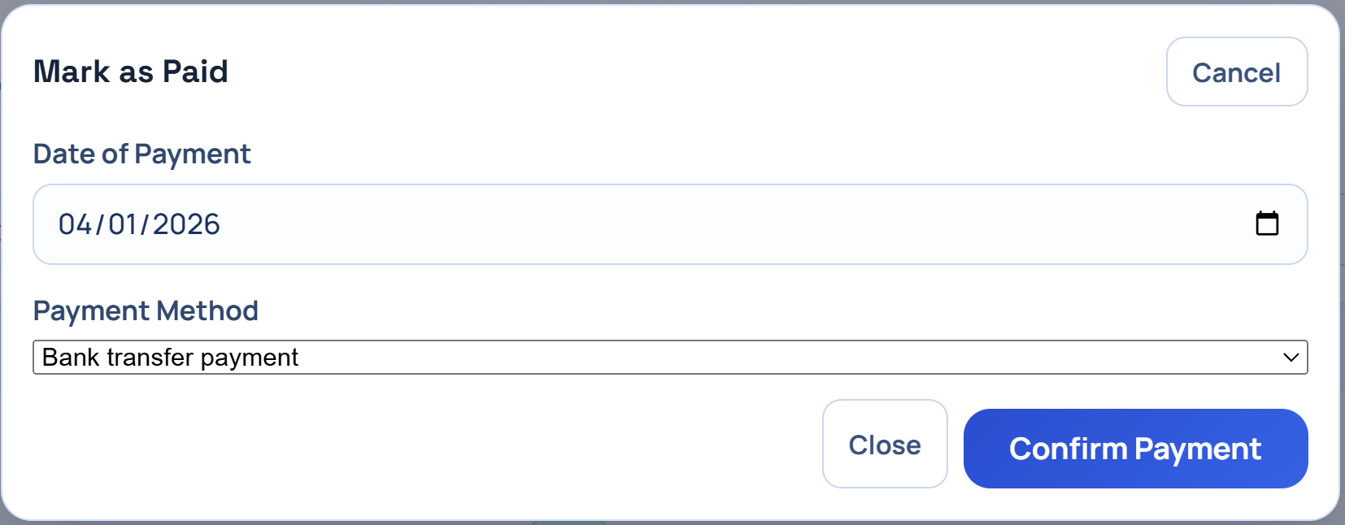

Tip: Understand Your App
It’s very important to understand the logic and structure of your apps. This way you can run specific prompts or request changes from AI more precisely. You can learn more about the files and what is contained in them by asking the chat to provide this information for you in a certain format. Here is one way of presenting this:
